**C_ITSP200 – Deliverable 6 - Complete**

**Cover page**

|  |  |
| --- | --- |
| **Group number and name** | 16 – MDMCT Processing |
| **Group member details** | PT2014–0007 – Minnie; Marius (leader)  PT2014–0465 – Volkwyn; Devon  PT2015–0747 – Henning; Margo  PT2014-0010 – Van der Walt; Christiaan  PT2012-0193 – Ferreira; Tiaan |
| **Project title** | Route 66 System |
| **Submission date** | 05/27/2016 |
| **Signature of group leader** |  |

**Table of contents**

1. Introduction 5

2. Deliverable 1 5

2.1 Group and customer information 5

2.2 System proposal 5

2.2.1 Overview 5

2.2.2 Aim 6

2.2.3 Objectives 6

2.2.4 User requirements 7

2.2.5 Required hardware and software 7

2.2.6 Schedule 8

2.2.7 Assumptions and constraints 8

2.2.8 Feasibility study: 10

2.2.9 Recommendations 12

3. Deliverable 2 13

Methodology 13

3.1 User requirements document 14

Introduction 14

3.1.1 Purpose 14

3.1.2 Scope 14

3.1.3 Definitions, acronyms and abbreviations 14

3.1.4 Overview 15

3.2 System requirements 15

3.2.1 System perspective 15

3.2.2 Functional requirements 15

3.2.3 Non-functional requirements 18

3.2.4 Technical requirements 18

3.2.5 User characteristics 19

3.2.6 Operational environment 19

4. Deliverable 3 20

Information systems design 20

4.1 Logical design 20

4.1.1 Create a logical data model (ERD) 20

4.1.2 Create a logical process model (DFD) Marius 21

4.2 Physical design 21

4.2.1 Investigation of technologies to be applied 21

4.2.2 System testing 23

4.2.3 System interface design 28

5. Deliverable 4 55

5.1 Information Systems Testing 55

5.1.1 Testing results 55

6. Deliverable 5 – Evaluation Report 58

6.1 Introduction 58

6.2 The final system and the customer’s requirements 58

6.3 Group dynamics and team collaboration 58

6.5 Lessons learnt 59

6.6 Conclusion 60

7. Deliverable 5 – User Manual 61

Introduction 61

Getting started 62

How to install 62

Instructions 62

7.1 How to log in 62

7.2 Non admin Employee Pages 64

7.2.1 Home Page: 64

7.2.2 Reserve Page: 67

7.2.3 Sale Page: 69

7.2.4 Customer Page: 72

7.3 Admin Pages: 74

7.3.1 Admin Home Page: 74

7.3.2 Sales Page: 77

7.3.3 Salaries Page: 79

7.3.4 Stock Page: 81

7.3.5 Reserve Page: 83

7.3.6 Customers Page: 86

7.4 Glossary 88

8. Conclusion 90

9. Customer sign-off 90

10. References 90

# Introduction

This Documentation covers all the work done in the Software project from start till end. The Route 66 System was developed to enhance the current system to be more efficient and incorporate more functions that can aid the business. Each Deliverable focus on certain aspects of the development of this system. From planning the system to final implementation. The Route 66 System Developed by MDMCT Processing Successfully meets all the business needs of the customer.

# Deliverable 1

## 2.1 Group and customer information

Group Name: MDMCT Processing

Group number: 16

Group Members:

PT2014–0007 – Minnie; Marius (leader)

PT2014–0465 – Volkwyn; Devon

PT2015–0747 – Henning; Margo

PT2014-0010 – Van der Walt; Christiaan

PT2012-0193 – Ferreira; Tiaan

Customer Details:

Customer Name: Susan

Customer Surname: Snyman

Company: Route66

Industry: Car selling business

## 2.2 System proposal

### 2.2.1 Overview

Route66 is a company that is part of the car dealership industry that specializes in selling muscle cars and other luxurious vehicles. This Company has one dealer principal and three sales staff members.

In terms of stock, Route66 always have a quantity of four of each car model, where one of the four will be used as a demonstration model.

The current system consists of staff members with responsibilities to record their sales on a spreadsheet, the administrator then determine commission for all the sales staff. After sales, have been made the administrator updates the stock spreadsheet.

Problems occurred previously when the administrator made a mistake and the stock spreadsheet was not updated accurately. Another problem that’s been putting unnecessary strain on the company is the fact that commission calculations often gets neglected and that causes salary delays.

When a car has been sold, the necessary details needs to be recorded of the sale and the car.

Solutions for the company’s current problems includes, implementing an automated system that includes a database with the necessary support for all functionality. With a brand, new functioning system, it is also necessary to provide user documentation in order for the staff to be able to use the system with ease.

Investing in an automated system as proposed, will solve many problems as well as errors in day to day processes. The system will also make Route66 a lot more efficient and accurate, it will also allow staff members to save time on their daily tasks and will result in the company being more productive.

In terms of security aspects, employee information and sensitive information as well as customer details and records of sales and accounts will be more secure, since the system will be implemented with admin and employee log in details and the system will be hosted from a secure server.

### 2.2.2 Aim

The aim of this project is to upgrade and implement Route66 business’ system from excel spreadsheet to more effective automated system.

### 2.2.3 Objectives

The following goals are seen as the objectives of the project.

* Conduct interview with client
* Obtain requirements and necessary information
* Setup System proposal
* Identify user requirements using user requirements documentation
* Identify required hardware and software
* Conduct and document feasibility study
* Make a list of recommendations to present to client
* Identify an appropriate methodology, techniques and tools to apply
* Setup designing documentation
* Setup testing documentation
* Implement system according to planning documentation
* Setup an evaluation report

### 2.2.4 User requirements

Functional:

* System Interface:

Minimalistic design, as simple as possible, be able to pull report, view total sales, and calculate salaries for employees, view/add/update/delete stock, add/delete/update employee, reserve add/update/delete, view/add/update/delete sales

Non-Functional:

* Validation: customer ID check, Completeness, basic validation
* Accessible goal: First demonstration in October
* Security: Onsite client server needed in secure room
* Administrator Security: Admin log in to access employee records

Technical:

* Current Software: currently have windows 7 and Office installed
* Current Hardware: currently have basic office setup for a total of 5 employees total
* Future Software: windows 7 and system application installed
* Future Hardware: 5 basic desktops and a secure server
* Developing language: c#

### 2.2.5 Required hardware and software

Hardware and Software Requirements for developers:

We require five computers, a computer for each developer.

On each developing computer the following is required:

* Windows operating system software
* Microsoft Visual Studio Software, which will be used to develop the application side of the system, this is where the programs will be written.
* Microsoft SQL Server Software, which will be used to develop the database side of the system which will hold all the records of the system
* Microsoft Office Software which include Word, which will be used to supply documentation of the system.
* OpenOffice Draw Software, which will be used to create diagrams which is part of the planning process
* Project Libre which will be used to keep track of progress and the schedule
* HP printer driver software, which will be used to be able to connect to the printer
* Keyboard, mouse, monitor, at least 4GB RAM, at least 30GB hard drive memory

Additionally, a HP printer is required to be able to print user documentation as well as necessary documentation which supports the planning process

Hardware and Software Requirements for Customers:

There are five employees currently employed which work on a basic desktop setup.

On each employee’s computer, the following is required:

* Windows Operating System Software
* Adobe PDF Reader, which will be used to open reports generated by the system
* Microsoft Office Software which includes Excel, which is currently used for basic tasks and will be used for smooth integration of new system
* HP printer driver software, which will be used to be able to connect to the printer
* Keyboard, mouse, monitor, 4GB RAM, at least 75GB hard drive memory

Additionally, a HP printer is required, which will be used by the employees to be able to print generated reports and documentation.

Hardware and Software Requirements for onsite Server:

* CPU: 2 x Intel Core 2 (2.66 Ghz, 128K cache)
* RAM: 2GB
* Minimum database space: 15GB
* Microsoft SQL Server Software, which will be used to store and access the database

### 2.2.6 Schedule

See Gantt chart on addendum A.

### 2.2.7 Assumptions and constraints

#### 2.2.7.1 Assumptions:

- The users already have the necessary computers as well as operating system installed

- The users have the basic computer skills

- There is no implemented system in a form of a software application

- The requirements and information given by customer is efficient and accurate

- The time available to complete the project is sufficient

- That a secure server will be setup

#### 2.2.7.2 Constraints:

- Training users to use the system

- Resources in terms of access to information about similar systems

- Resources in terms of information about techniques and tools for planning and analysis

|  |  |  |  |
| --- | --- | --- | --- |
| Feasibility criteria 2.2.8 Feasibility study: | Ranking | System option 1:  Purchase commercial off-the-shelf package for member services | System option 2:  Write new application in-house using new company standard |
| Operational feasibility | 30% | Only member services requirements would be supported. The business processes that currently take place would have to be modified in such a matter in order to take full advantage of the software and what it offers.  Score: 65 | When writing a new system completely from scratch, it is custom made to serve every user-required functionality as well as all the business processes that have to take place  Score: 100 |
| Technical feasibility | 30% | Packages that are available have frequent new versions available, but at extra costs for each upgrade. The development of the product is a risk. Monthly fees are added to the product in order to receive technical support if something happens to the system or if the users have any queries.  The integration of the system is quite complex so Java expertise would have to be hired or trained in order to perform modifications.  Score: 45 | Expertise:  The solution requires writing the application in C#. The development team already know how to work with this language so there will be no problem in the actual development of the system.  Technology:  The current computers are very basic but will easily be able to complete the tasks that have to be completed.  Score: 95 |
| Feasibility criteria | Ranking | System option 1:  Purchase commercial off-the-shelf package for member services | System option 2:  Write new application in-house using new company standard |
| Economic feasibility | 30% | Cost: R20 000 (Approximately)  Benefits:   * Proven existing solution and ready to be used. * No need for constant maintenance. * Proven track record.   Score: 80 | Cost: R 25 000  Benefits:   * The company has full ownership of the final product as well as its source code and the knowledge gained while developing it. * Fits exactly to the business requirements of the company * It gives you full control over the system and its functionality * Can provide the business with a greater competitive advantage that a bought solution.   Score:80 |
| Schedule feasibility | 10% | 3 Months  Score: 85 | 5 – 6 Months  Score: 70 |
| Ranking |  | 65.5 | 89.5 |

### 2.2.9 Recommendations

We recommend System option 2, the In-house development.

With In-house development you will receive a newly designed system that meets your specific needs and requirements.

Route 66 will have full ownership of the final product, as well as its source code and the knowledge gained while developing it. If the off-the-shelf-package is used, then the vendor has the rights to the code.

There is a relationship between the development team and the user base, which helps in communication and expectation delivery, also if you might come across any issues in future use it will be sorted out immediately, compared to off-shelf-package, you might have the inconvenience of dealing with a faulty system for a period of time as the company Route 66 will have to rely on the vendor for technical support.

As the system is developed for your specific needs, it provides you with a greater competitive edge above your competitors and also provide you with a better customer service, for example an employee will no longer have to run around and leave a customer unattended at his/her desk.

With in-house development the system functionality is determined by you, compared to off-shelf-package the system functionality is determined by the vendor witch might not always meet your requirements and needs.

# Deliverable 2

## Methodology

Waterfall Methodology:

In the waterfall model every stage must be finished completely before the following stage can start. This sort of methodology or model is fundamentally utilised small project and there are no unverifiable prerequisites. Toward the end of every stage, a survey happens to figure out whether the plan is on the right way and whether to proceed or dispose of the plan or project. In this model the testing begins simply after the development is finished (Istqbexamcertification.com, 2016). Stages do not overlap in the waterfall methodology. The advantages of this model are as follows; this model is basic and straightforward and use. It is anything but difficult to oversee because of the inflexibility of the model – every stage has particular deliverables and a survey procedure. The stages are prepared and finished each in appropriate turns. Waterfall model functions perfectly for littler undertakings where necessities are extremely understood. The waterfall model can be used when the requirements, technology and innovation are understood, fixed, and altered. When the definition of the product is stable and there are no vague prerequisites. When abundant assets with required skill are accessible uninhibitedly and the plan is short (Istqbexamcertification.com, 2016).

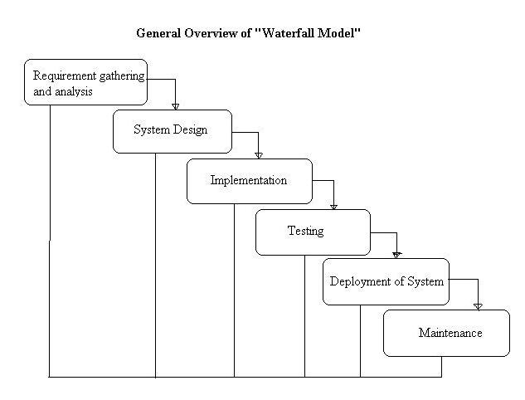

## 3.1 User requirements document

## Introduction

In this section the purpose of the system will be explained including the readers and type of information system. A scope about the system will also be given and explain everything the system will do as well as any complex terms that may have been used will be explained.

### 3.1.1 Purpose

The type of information system will be a transaction processing system that collects data, stores data, processes data and delivers an output. All the information and specification about the cars that’s available will be entered onto the system and then the system will calculate and be able to provide an employee of the necessary info if a customer is interested in a certain car. The CEO of the company will be the recommended reader of this document and will need to provide the employees of the necessary info.

### 3.1.2 Scope

The system will provide an employee with all the necessary information about a requested vehicle and also tell the employee if there is any stock available of the requested vehicle and also if there is any reserve on the car in other word if there is anyone interested in buying that car and waiting for financing on the vehicle .

Benefits of this system is that a customer’s questions can be answered immediately about the car because everything will be shown to the employee on his/her computer no customer will leave the shop unanswered. A Customer will no longer have to be left alone or unattended at an employee’s desk due to the employee having to run around and collecting info. The goal of this system is to be able to provide a customer with what he/she needs and not to have customers wait on a specific car that he/she requested, to be able to immediately tell them yes the car is still available or no its been sold or currently has a reserve on it. So this system will improve customer service and by doing so also improve the sales of the company. The system will also help with the administration e.g. if the employee sells a car his commission will be calculated and added to his/her basic salary.

### 3.1.3 Definitions, acronyms and abbreviations

**Transaction processing system (TPS)** - it is basically a system that stores, collects and processes data that it receives. The processed data will then be delivered as an output.

**Functional requirements:** Most requirements definition focuses mainly on functional requirements, which are based upon the expected functioning of the product or system to be created. Functioning, typically is equated with product/system features for which you might have a menu or button choice

**Non-functional requirements**: a Requirement that specifies criteria that can be used to judge the operation of a system e.g. performance levels, security.

**Technical requirements:** pertains to the technical aspects that your system must fulfil, such as performance-related issues, reliability issues, and availability issues.

**Context Diagram (High-level DFD):** A diagram that describes the main processes that is associated with the system end the main entities working with the system.

**Entity Relationship diagram (ERD):** A diagram that illustrates the relationships between different entities and also displays the different attributes of these entities.

### 3.1.4 Overview

In section 2 the system requirements will be discussed everything you need for your system to work at its absolute best. The system perspective is discussed and also how the system compares to other systems, the functional, non-functional and technical requirements of the system will also be listed and explained.

## 3.2 System requirements

The purpose of this section is to explain the system requirements. The requirements will be used as a measure to assess customer acceptance (whether all the requirements have been met).

### 3.2.1 System perspective

A standalone system refers to a software program that doesn’t need any software other than the operating system to run.

Software like plug-ins and expansion packs are not standalone software programs, since they will not run unless a certain program is already installed.

Therefore the Route66 system is a standalone system which doesn’t relate to any other systems and is also not dependent on any other system beside the operating system.

### 3.2.2 Functional requirements

|  |  |  |  |
| --- | --- | --- | --- |
| **Unique Identifier** | **Name** | **Description** | **Priority** |
| REP01 | Generate report | Be able to pull a full report on all data | high |
| SALE01 | View sales | View all sales or individual sales | High |
| SALE02 | Add sales | Add sales to records as sales are made | High |
| SALE03 | Update sales | Update sales records | High |
| SALE04 | Delete sales | Delete sales from records incase needed | High |
| STOCK01 | View Stock | View all stock available | High |
| STOCK02 | Add stock | Add stock to stock records | High |
| STOCK03 | Update stock | Update stock records | High |
| STOCK04 | Delete stock | Delete stock from records incase needed | High |
| EMP01 | Add employee | Add employee to employee records | High |
| EMP02 | View employee | View all or individual employee records | High |
| EMP03 | Update employee | Update employee records when needed | High |
| EMP04 | Delete employee | Delete employee record when needed | High |
| RES01 | View reserves | View items that’s been reserved | High |
| RES02 | Add reserves | Add items that’s being reserved | High |
| RES03 | Update reserves | Update items that’s been reserved | High |
| RES04 | Delete reserves | Delete items that’s been reserved | High |
| CUST01 | View customers | View all customers or individual customer | High |
| CUST02 | Add customer | Add customer to records as sales are made | High |
| CUST03 | Update customer | Update customer records | High |
| CUST04 | Delete customer | Delete customer from records incase needed | High |

#### 3.2.2.1 A context diagram (high-level DFD)

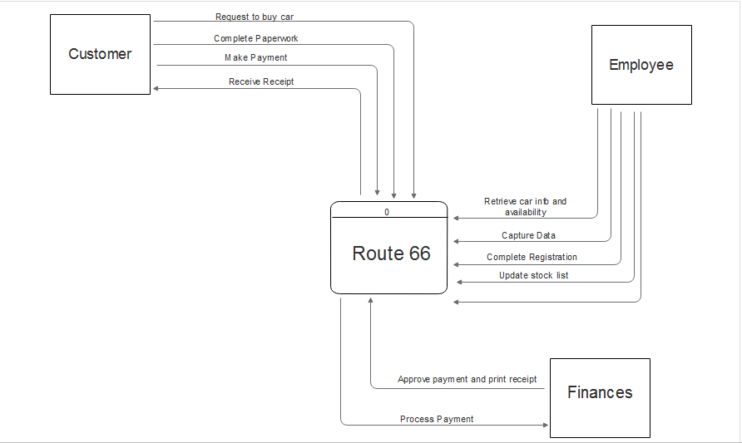

#### 3.2.2.2 An entity relationship diagram (ERD)

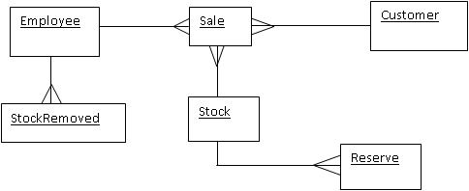

### 3.2.3 Non-functional requirements

Validation requirements: Check all entered personal IDs with algorithm, Completeness, basic validation to filter for liable information

Accessible goal: First demonstration in October

Admin Users will have access to every part of the system where normal users will have limited access to the system

Security requirements: Onsite client server needed in secure room

Administrator Security: Admin log in to access employee records and other sensitive information as well as calculate employees’ commission

Non-complex Interface Design: Minimalistic interface design, which is kept as simple as possible

### 3.2.4 Technical requirements

The product will be licensed to Route 66 Auto, there will also be no constraints to the system where the customer must pay additional fees or monthly fee to unlock the full potential of the full system capabilities that they will be using from us. All sensitive data will be encrypted and send over safe and secure channels.

* Programming language: Visual Studio (C#)
* Operating System: From Windows 7 and newer versions of windows
* Database Application: Microsoft SQL Server Management Studio
* Security: Encrypting software

### 3.2.5 User characteristics

* **Client:**  Some users using the system software can have an expertise level of novice to expert.

With that being said, some users may be familiar with similar systems that they used in the past and other users may not be able to use the system as they are not familiar using systems that does all the paper work they are used to.

The language of the system will be built in the common business language which is English as this the most common language people can read and write.

Our system interface and relating functions will be created in such a manner that it compliments and aids users who are at a novice level at the same time not affect the performance of expert users.

### 3.2.6 Operational environment

The computers will be using Windows 7 for each workstation; all workstations will be pre-loaded with the API (Application Programming Interface) also with the operating system and all the other technical software that was enlisted.

The machines will also have a backup folder on the server computer where all the drivers are saved for example: printer, technical software, backed up database data also all the excel spread sheets that were previously used.

The workstations will be connected by one network that will connect all the workstations from each department and also the printers. The workstations will have one computer per desk for each employee. Certain workstations will have their own personal printer while other workstations will share a printer that is connected to the network.

# Deliverable 3

## Information systems design

## 4.1 Logical design

Logical design is an abstract or conceptual design. Logical design involves arranging data into a series of logical relationships called attributes and entities of the system. The design illustrates communications between these entities and attributes without going into much detail. Great examples of logical design methods that are also used in this project are DFD's (Data flow Diagrams) and ERD's (Entity relationship Diagrams) which are used to diagram logical designs.

(Thario: 2016)

(Oracle: 2016)

### 4.1.1 Create a logical data model (ERD)

Customer

#*CustID

*IDno

*Name

*Surname

*CellNo

*Email

*CustAddress

Sale

#*SaleID

*SaleDate

Reserve

#*ResID

*ResDate

*Name

*Surname

*IDno

*CellNo

*Email

Stock

#*StockID

*VIN

*VehicleYear

*Model

*Make

*VehicleStatus

*Price

StockRemoved

#*StockRemovedID

*DateRemoved

*ReasonRemoved

*VIN

Employee

#* EmpID

* IDno

* Name

* Surname

* Username

* Pass

* CellNo

* Email

* EmpAddress

* Salary

* IsAdmin

* Activated

### 4.1.2 Create a logical process model (DFD) Marius

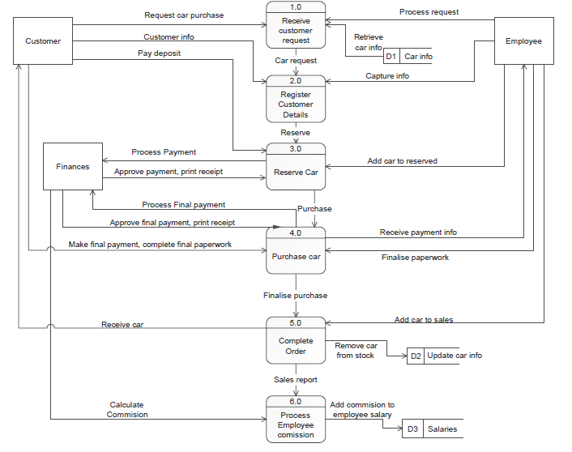

## 4.2 Physical design

It is the actual I/O processes of the system. It show how the data is inserted into the system then the data is processed and then it is displayed as an output. The physical design can also been as a graphical representation of a system internal and external entities, and the flows of data into and out of these entities.

The user interface design is how the users add information to the system and with how the system presents the information back to the user. Data design is concerned with how the data is represented and stored within the system. Process design controls how the data moves through the system, where it is validated, transformed and secure to move through the system.

### 4.2.1 Investigation of technologies to be applied

1. Hardware
   1. RAM

There will be for every workstation an allocated size of RAM installed into each workstation computer. The server will use much more RAM than the workstations. Workstations will have 8GB of RAM installed and the server will have a minimum of 32GB.

* 1. CPU

The same method will be applied to the CPU as the way RAM was implanted to the workstations and the server. Each workstation will be installed with an AMD A8-5600 APU 3.6GHz. The server will be installed with an AMD Opteron A1100.

* 1. Server

The server will be located on in a safe area on site. This will be a standard server that will serve for storage and I/O from the users on the network.

* 1. Monitor

Standard 18.5” inch monitors will be used by each employee.

* 1. Printer

Printers will be allocated to only certain workstations then there will be a central printer that will be connected on the network that all workstations can print from.

* 1. CAT5 cables

The cable will be used to connect the whole system (workstations, printers, server and internet) as an extranet.

* 1. Switches

Switches will act as a gateway for the workstations to communicate within the intranet.

* 1. Routers

This will allow the users within the intranet to communicate to the internet by using DMZ.

* 1. DMZ

DMZ is a computer host inserted between a company’s private network and the outside public network. This allows users from the intranet to connect to the internet, thus not allowing users from the outside to connect to the private network.

1. Software
   1. Windows 7 and newer versions of windows

All workstations will run windows 7 or newer versions of windows.

* 1. Visual Studio(C#)

This will be used to code the actual system that was requested from the client.

* 1. MySQL

This will act as the database on the server that will store all data of clients and records of the company.

* 1. Encrypting software

This software will be used to send sensitive data over safe and secure channels. Data will allows be encrypted when sending over the network and then be decrypted on arrival of the destination over the network.

* 1. Windows Server 2008

This will be used to run the operating system on the server and all network configurations will be made on this operating system.

### 4.2.2 System testing

**Testing types**

System testing consists of the testing of a complete fully integrated software product. System testing includes a series of different tests to exercise the full computer based system.

System testing falls under black box testing. Black box testing is a method used to examine the functionality of an application without peering into its internal structures. ("Graphical User Interface Testing")

In system testing you test the code for the following:

1. Testing fully intergraded applications including external peripherals in order to check how components interact with one another. This is called End to End testing.
2. Testing every input in the application to check for desired outputs (“what is system testing”)

1. Graphical user interface testing = the process of testing a products GUI to ensure it meets its specifications.

2. Usability testing = Focuses on measuring a human-made products capacity to meet its intended purpose.

3. Software performance testing = a testing practice performed to determine how a system performs in terms of responsiveness and stability under a particular workload.

4. Compatibility testing = part of software non-functional tests, testing to evaluate the application compatibility with the computing environment.

(Computing environment contains for e.g. hardware platform, bandwidth handling capacity, compatibility of peripherals etc.)

**Testing templates**

Graphical user interface testing

* GUI testing is the process of ensuring proper functionality of the graphical user interface for a given application and making sure it conforms to its written specifications

|  |  |  |  |
| --- | --- | --- | --- |
| **Test plan – Graphical user interface test** | | | |
| **Test type** | Test date | Team member | Comments |
| **Size of characters, buttons etc.** |  |  |  |
| **Width of characters, buttons etc.** |  |  |  |
| **Visual display of characters, buttons etc.** |  |  |  |
| **Functionality Login: logging in as the requested user?** |  |  |  |
| **Functionality Exit: Logging out of current user profile?** |  |  |  |
| **Functionality adding a record: Adds Car to database?** |  |  |  |
| **Functionality: removing record: removing requested record from database?** |  |  |  |
| **Functionality making a sale: removing record from database and also adding it so designated customer’s name?** |  |  |  |
| **Error messages displaying correctly?** |  |  |  |
| **Is the font displayed in a readable format?** |  |  |  |
| **All images aligned correctly and displayed correctly?** |  |  |  |

Usability testing

* Usability testing is a technique used in [user-centered](https://en.wikipedia.org/wiki/User-centered_design) [interaction design](https://en.wikipedia.org/wiki/Interaction_design) to evaluate a product by testing it on users. This can be seen as an irreplaceable [usability](https://en.wikipedia.org/wiki/Usability) practice, since it gives direct input on how real users use the system

|  |  |  |  |
| --- | --- | --- | --- |
| **Test plan – Usability Testing** | | | |
| **Test type** | Test date | Team member | Comments |
| **Login : is the correct users profile being opened** |  |  |  |
| **Exit: is the current profile being closed and taken to the login screen?** |  |  |  |
| **Add : is a car being added to the database after “Add” button is clicked** |  |  |  |
| **Delete : is a record being removed from the database after “Delete” button is clicked** |  |  |  |
| **Make sale : is an added to the correct customers profile** |  |  |  |

Software performance testing

* In [software engineering](https://en.wikipedia.org/wiki/Software_engineering), performance testing is in general, a [testing](https://en.wikipedia.org/wiki/Software_testing) practice performed to determine how a [system](https://en.wikipedia.org/wiki/System) performs in terms of responsiveness and stability under a particular workload

|  |  |  |  |
| --- | --- | --- | --- |
| **Test plan – Software performance testing** | | | |
| **Test type** | Test date | Team member | Comments |
| **Is the program performing on a constant level** |  |  |  |
| **Is the program loading all the correct labels, buttons etc.?** |  |  |  |
| **Is all images displayed immediately on the loaded screen** |  |  |  |

Compatibility testing

* Part of [software](https://en.wikipedia.org/wiki/Software) [non-functional tests](https://en.wikipedia.org/wiki/Non-functional_tests), is testing conducted on the [application](https://en.wikipedia.org/wiki/Application_software) to evaluate the application's [compatibility](https://en.wikipedia.org/wiki/Computer_compatibility) with the computing environment

|  |  |  |  |
| --- | --- | --- | --- |
| **Test plan – Compatibility testing** | | | |
| **Test type** | Test date | Team member | Comments |
| **Is the system Reacting to the hardware components such as mouse, keyboard, screen and printer?** |  |  |  |
| **Is the system communicating With the server?** |  |  |  |
| **Can data be added to the database?** |  |  |  |
| **Can data be deleted from the database?** |  |  |  |

|  |
| --- |
| **Note** |
| Example:  Two unit tests to test functionality and usability, as well as a systems test when the system has been completed. |

**Test plan**

This Test Plan has been created to communicate the test approach to team members. It includes the testing types that will be conducted, the dates that the tests will take place and the team members taking part in the process. This document will clearly identify what the test deliverables will be and what is deemed in and out of scope.

|  |  |  |  |
| --- | --- | --- | --- |
| **Test plan – Graphical user interface test** | | | |
| **Test type** | Test date | Team member | Comments |
| **Are all of the controls and the content of the program of the same size and in proportion?** | Monday, 29 August 2016 | Devon Volkwyn |  |
| **Is everything in the interface properly visible to the user and not harsh on the eye?** | Monday, 29 August 2016 | Tiaan Ferreira |  |
| **Error messages displaying correctly?** | Monday, 29 August 2016 | Margo Henning |  |
| **Is the font displayed in a readable format?** | Monday, 29 August 2016 | Tjaart Walt |  |
| **All images aligned correctly and displayed correctly?** | Monday, 29 August 2016 | Marius Minnie |  |
| **Is the font used consistent throughout the system?** | Monday, 29 August 2016 | Devon Volkwyn |  |
| **Is the content well organised on each page or does it look cluttered?** | Monday, 29 August 2016 | Marius Minnie |  |

|  |  |  |  |
| --- | --- | --- | --- |
| **Test plan – Usability Testing** | | | |
| **Test type** | Test date | Team member | Comments |
| **Login : is the correct users profile being opened** | Tuesday, 29 August 2016 | Tjaart Walt |  |
| **Exit: is the current profile being closed and taken to the login screen?** | Tuesday, 29 August 2016 | Margo Henning |  |
| **Can you properly search for records described to the system?** | Tuesday, 29 August 2016 | Tiaan Ferreira |  |
| **Add : is a car being added to the database after “Add” button is clicked** | Tuesday, 29 August 2016 | Marius Minnie |  |
| **Delete: is a record being removed from the database after “Delete” button is clicked?** | Tuesday, 29 August 2016 | Devon Volkwyn |  |
| **Make sale: is the sale added to the correct customer’s profile?** | Wednesday, 29 August 2016 | Tiaan Ferreira |  |
| **Does admin have extra privileges when using the system and only admin?** | Wednesday, 29 August 2016 | Tjaart Walt |  |
| **Do you feel that the feedback from the system is well detailed and informs you properly?** | Wednesday, 29 August 2016 | Margo Henning |  |

|  |  |  |  |
| --- | --- | --- | --- |
| **Test plan – Software performance testing** | | | |
| **Test type** | Test date | Team member | Comments |
| **Is the program performing on a constant level?** | Thursday, 29 August 2016 | Devon Volkwyn |  |
| **Does all content on each page load efficiently and correctly?** | Thursday, 29 August 2016 | Margo Henning |  |
| **Are the system requirements earlier provided to the customer viable for the created system?** | Thursday, 29 August 2016 | Marius Minnie |  |
| **Is there any form of lag or delay present when working on the system?** | Thursday, 29 August 2016 | Tiaan Ferreira |  |

|  |  |  |  |
| --- | --- | --- | --- |
| **Test plan – Compatibility testing** | | | |
| **Test type** | Test date | Team member | Comments |
| **Is the system Reacting to the hardware components such as mouse, keyboard, screen and printer?** | Friday, 29 August 2016 | Tjaart Walt |  |
| **Is the system communicating With the database?** | Friday, 29 August 2016 | Marius Minnie |  |
| **Can data be added to the database?** | Friday, 29 August 2016 | Margo Henning |  |
| **Can data be deleted from the database?** | Friday, 29 August 2016 | Devon Volkwyn |  |

### 4.2.3 System interface design

**1. Welcome Page:**

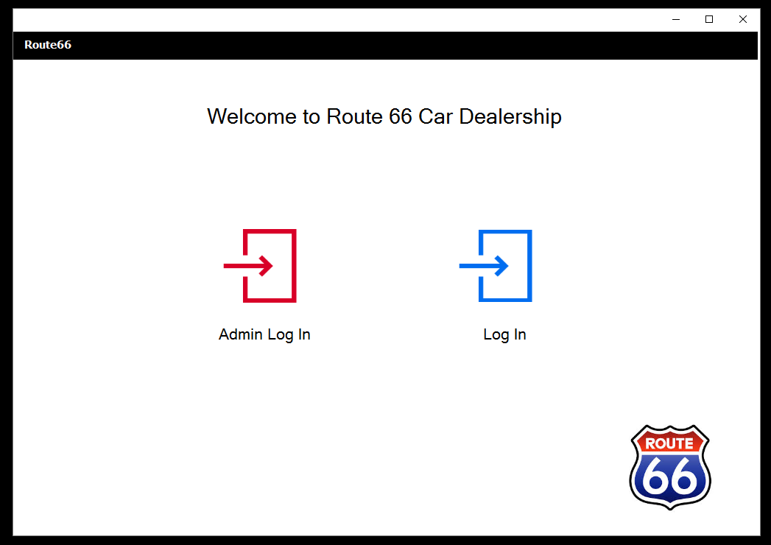

**2. Log In pages:**

2.1 Normal Employee Log In page:

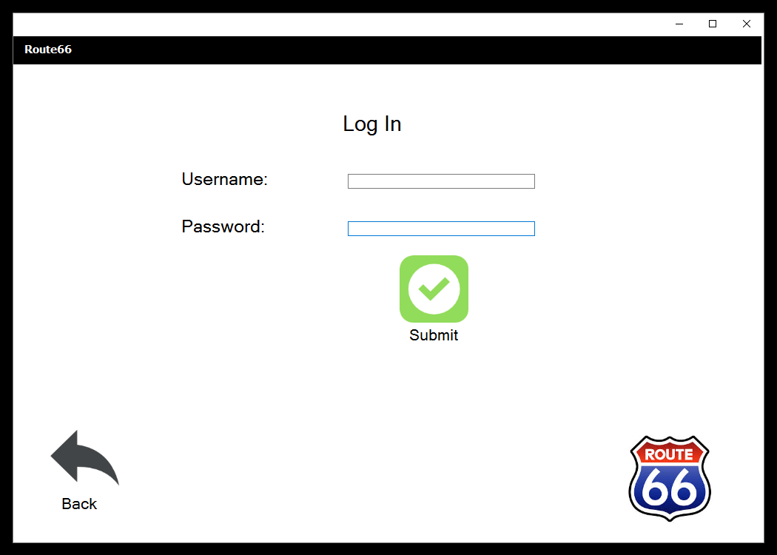

2.2 Admin Log In page:

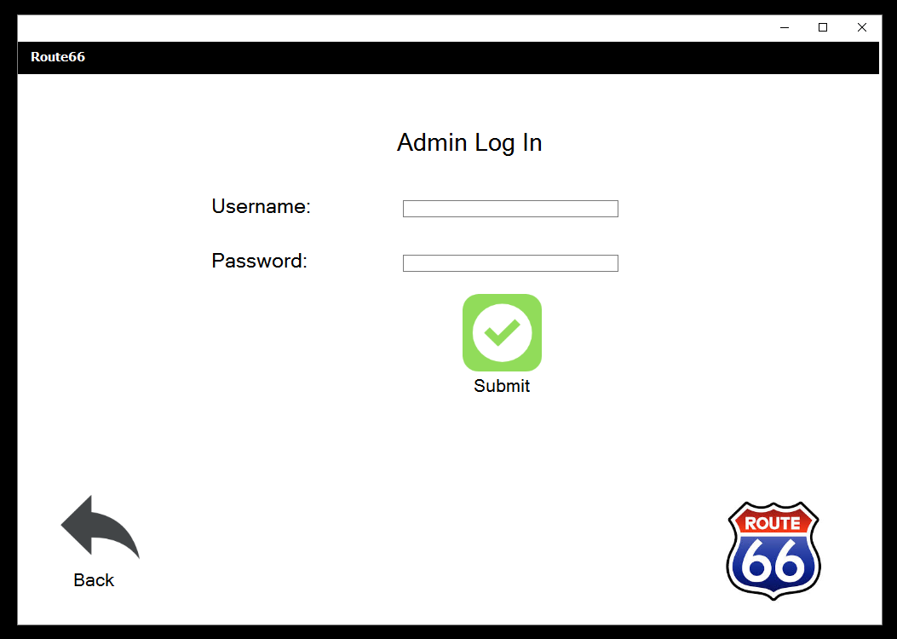

**3. Normal Employee Pages:**

3.1 Home Page:

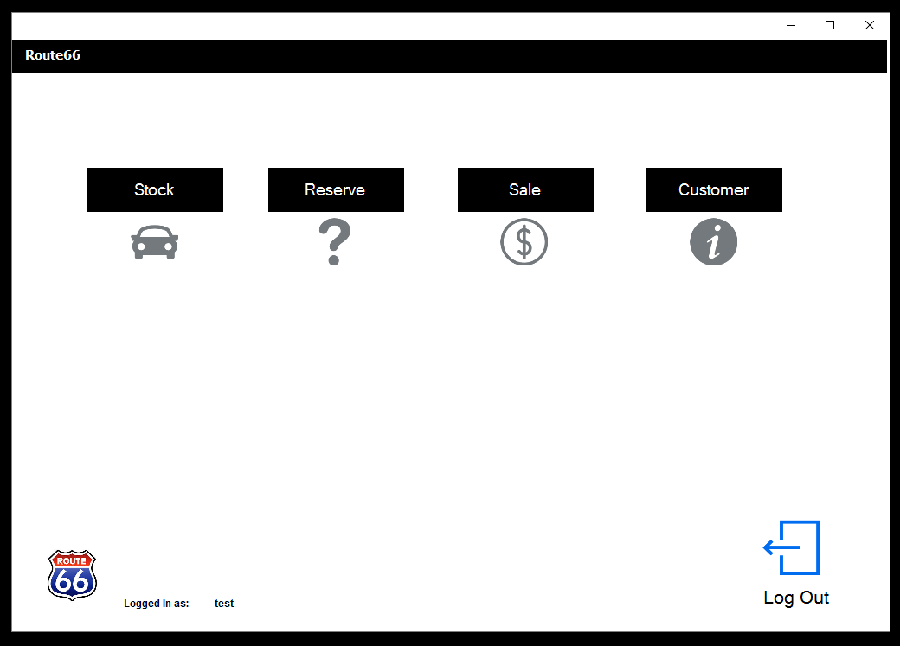

3.2 Stock Page:

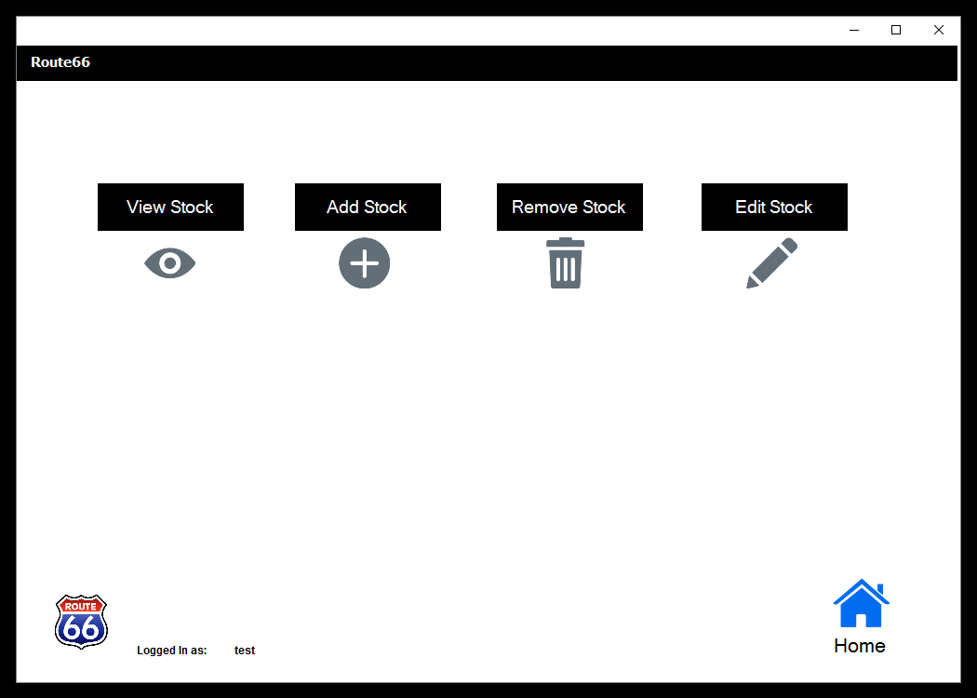

3.2.1 View Stock Page:

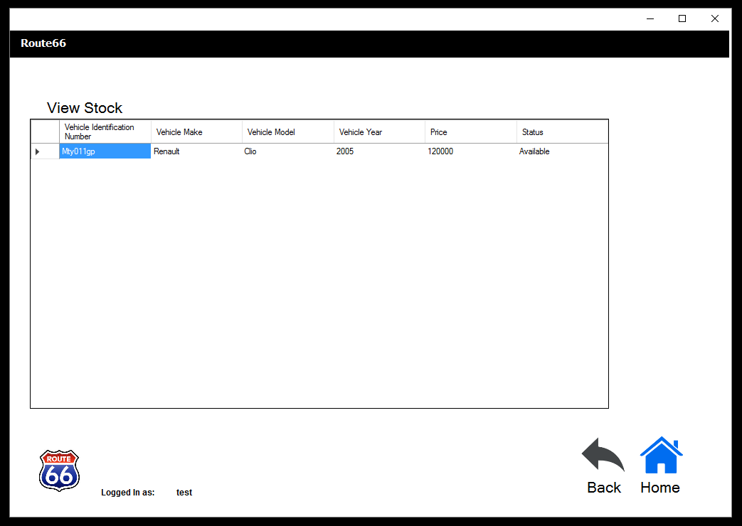

3.2.2 Add Stock Page:

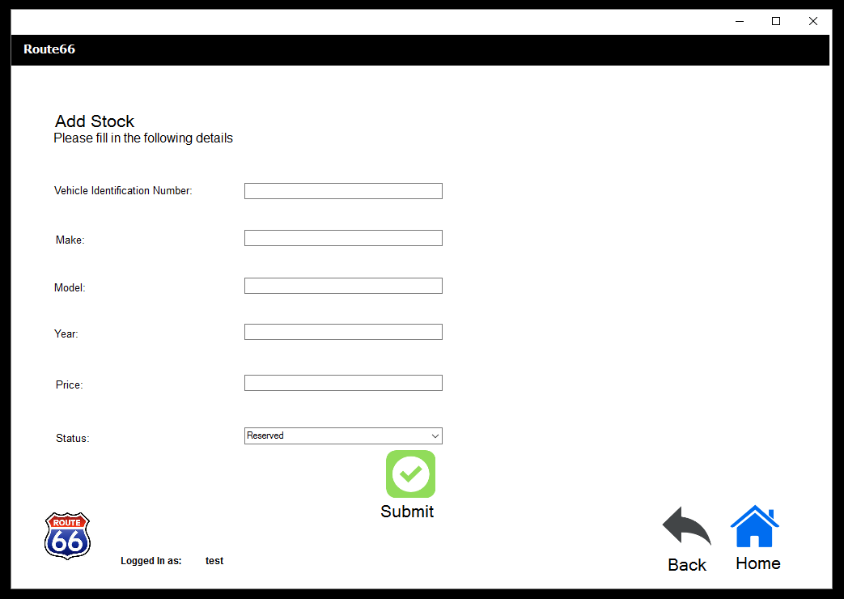

3.2.3 Remove Stock Page:

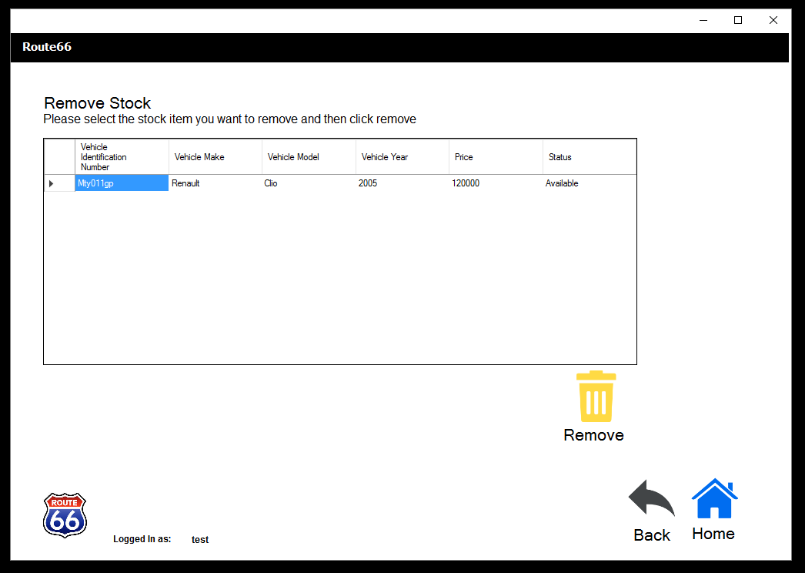

3.2.4 Edit Stock Page:

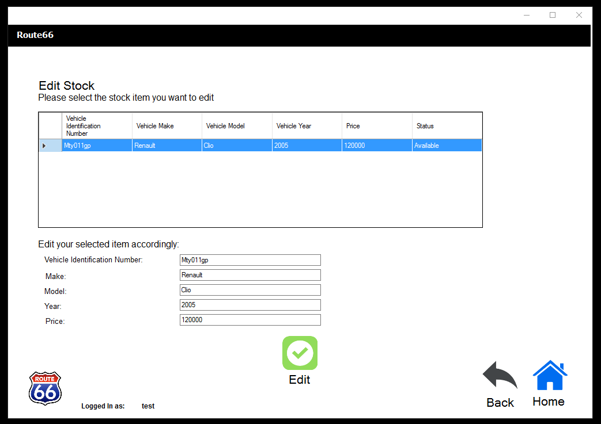

3.3 Reserve Page:

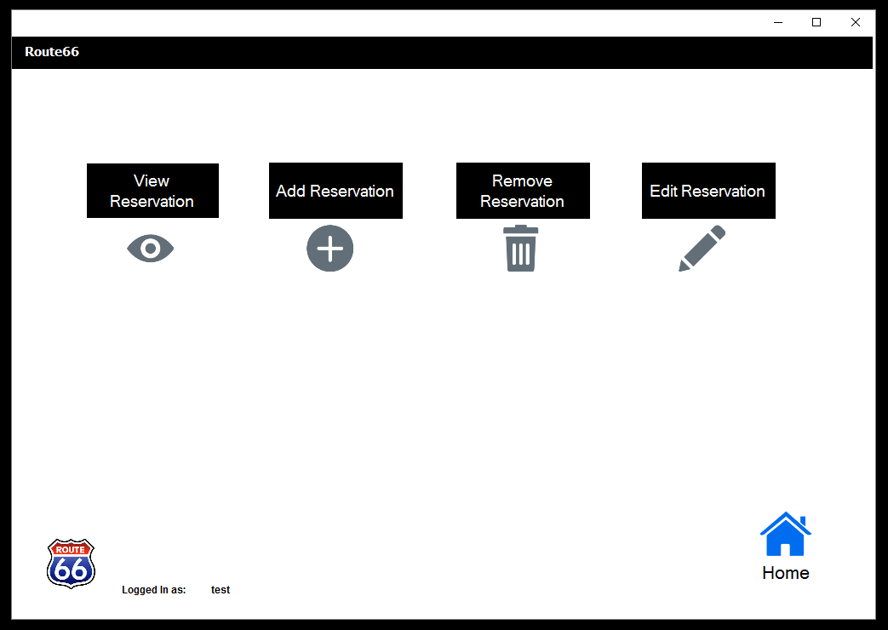

3.3.1 View Reservation:

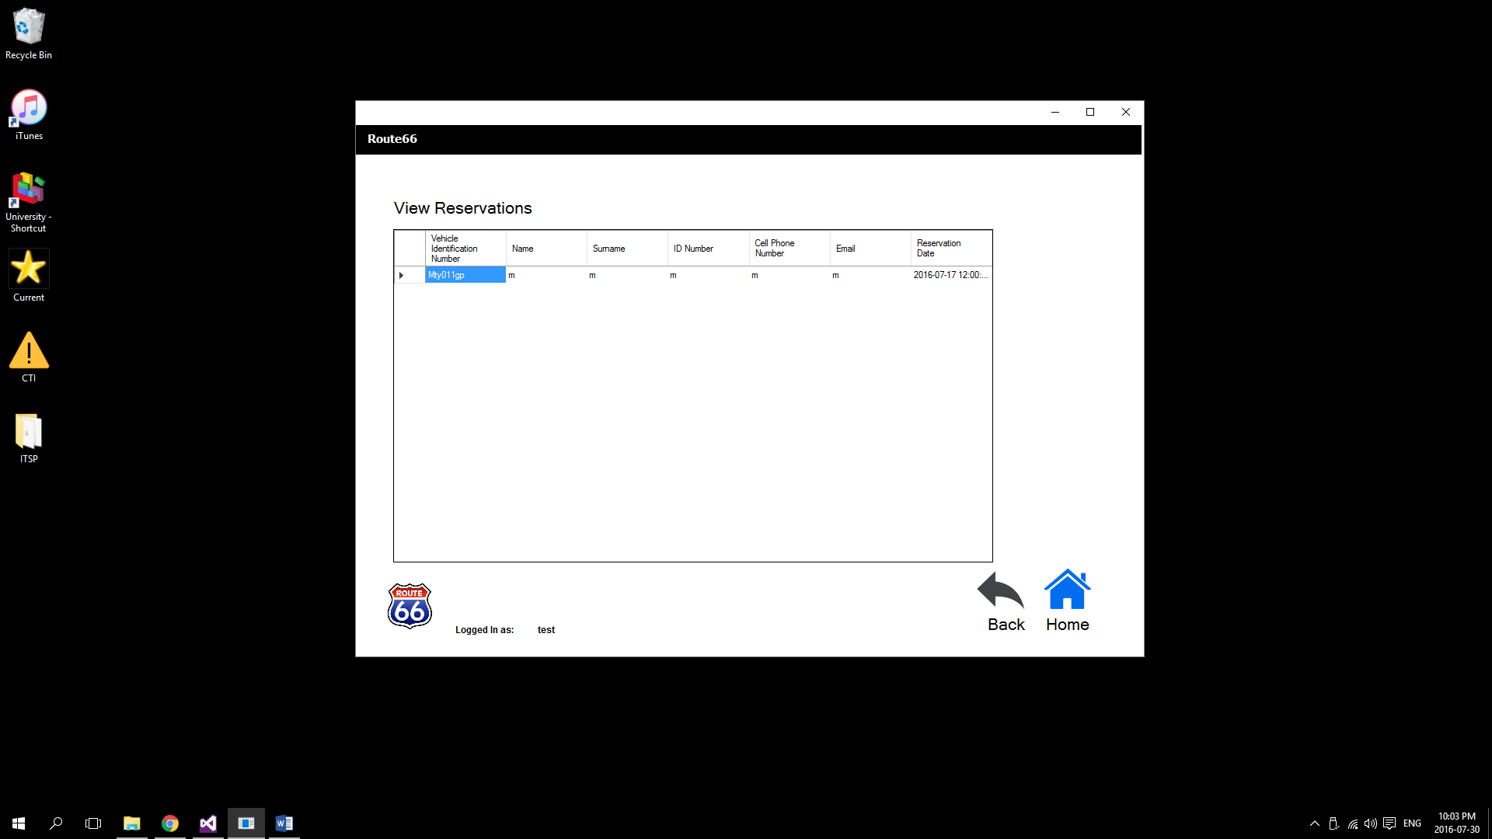

3.3.2 Add Reservation:

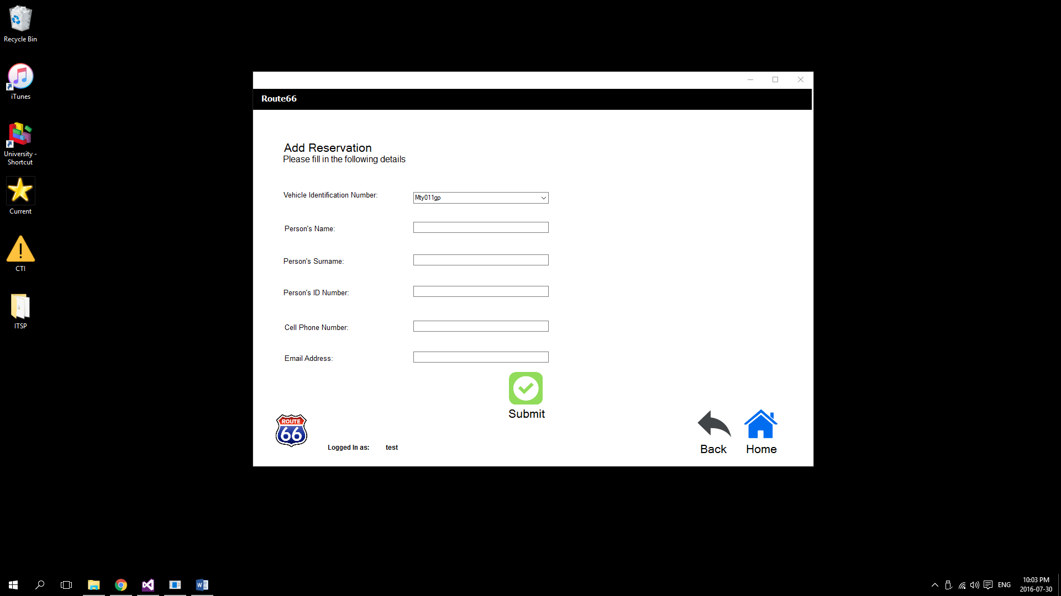

3.3.3 Remove Reservation:

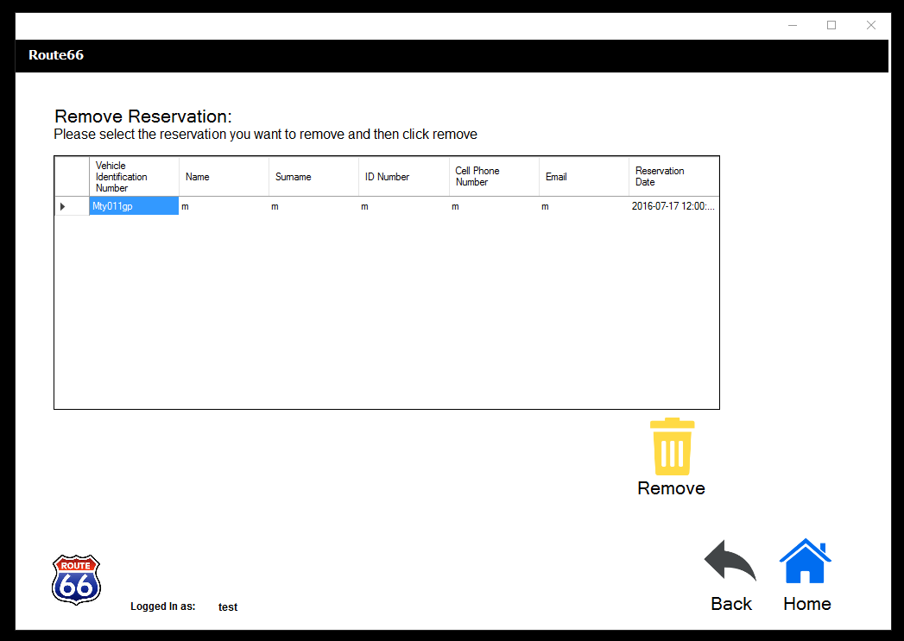

3.3.4 Edit Reservation:

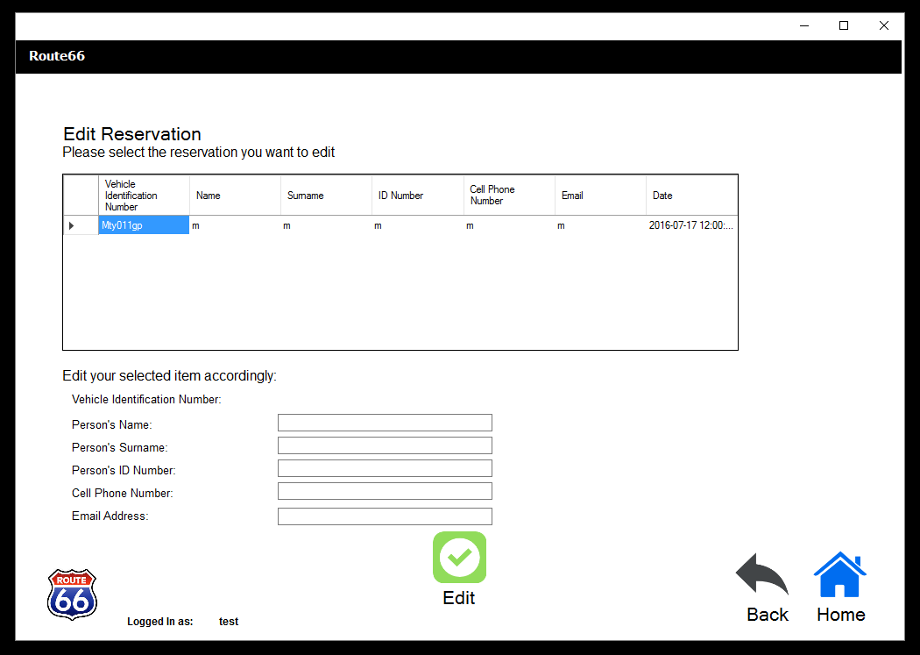

3.4 Sale Page:

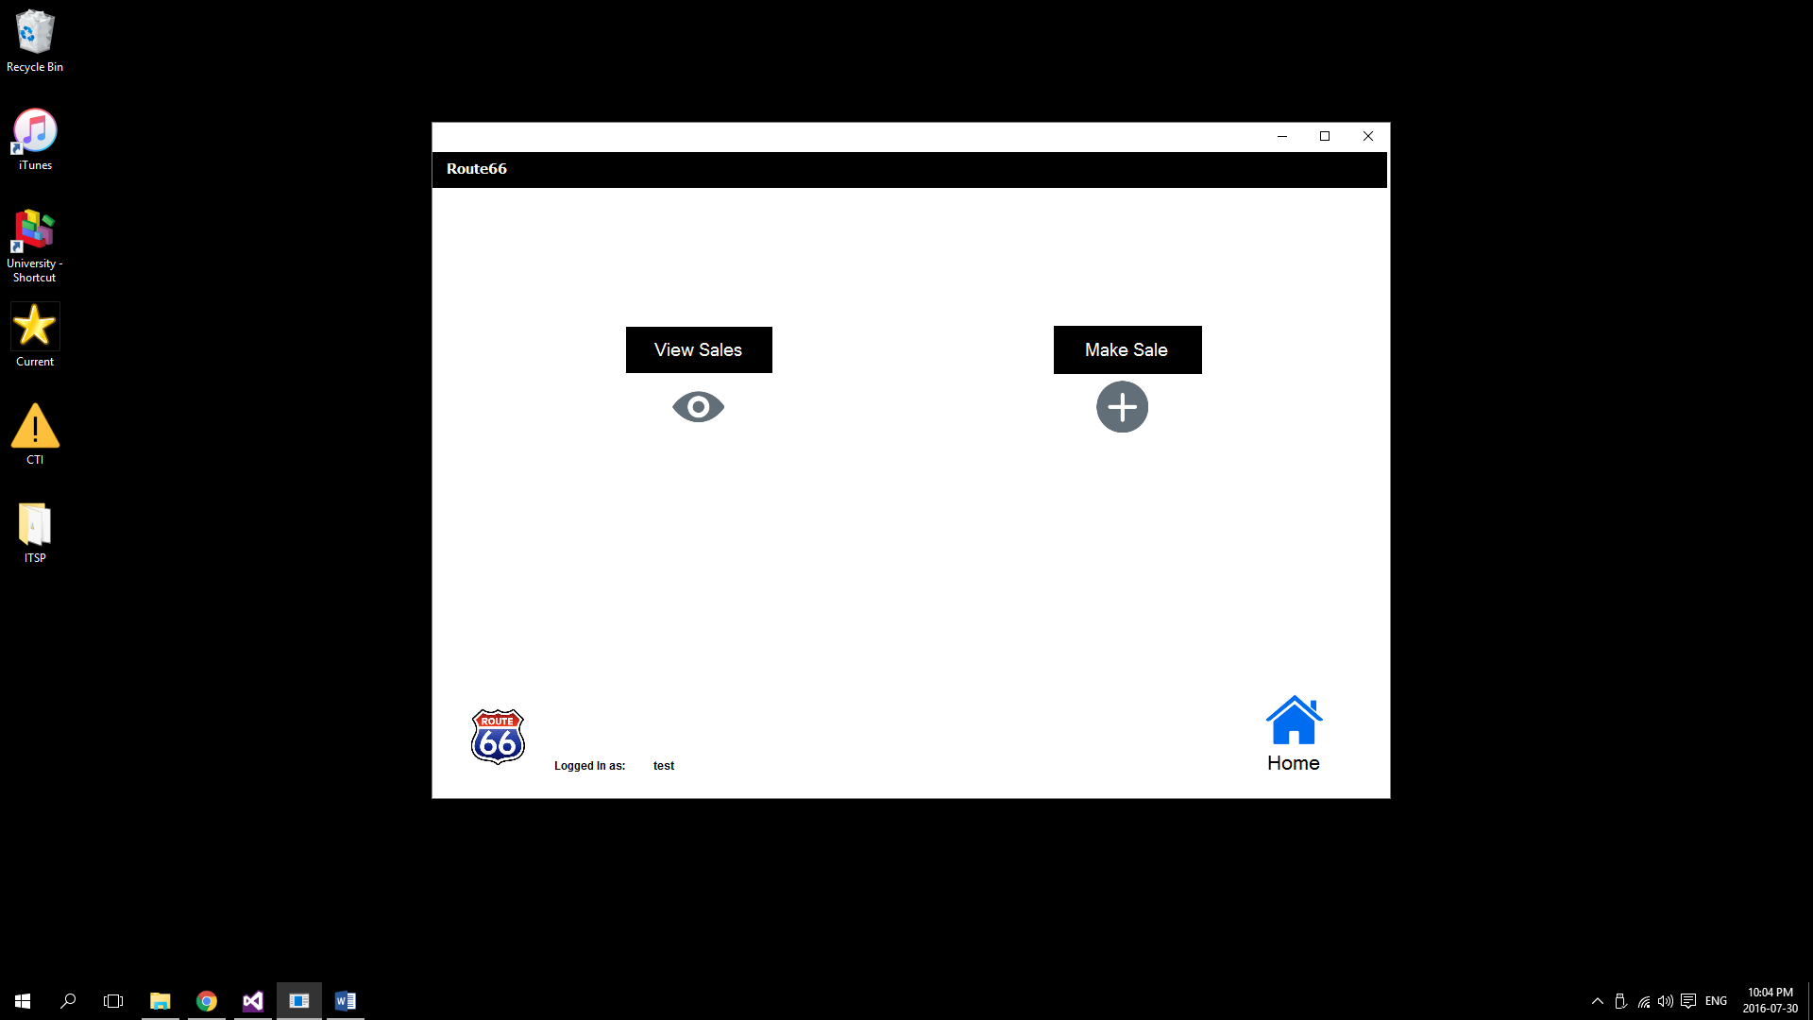

Make Sale (Admin)

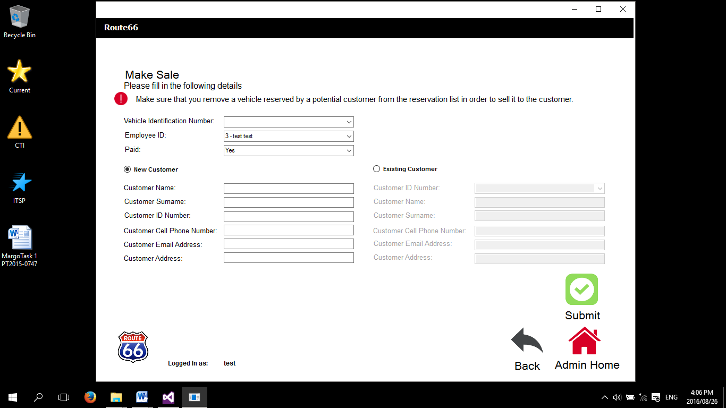

Make Sale (Normal)

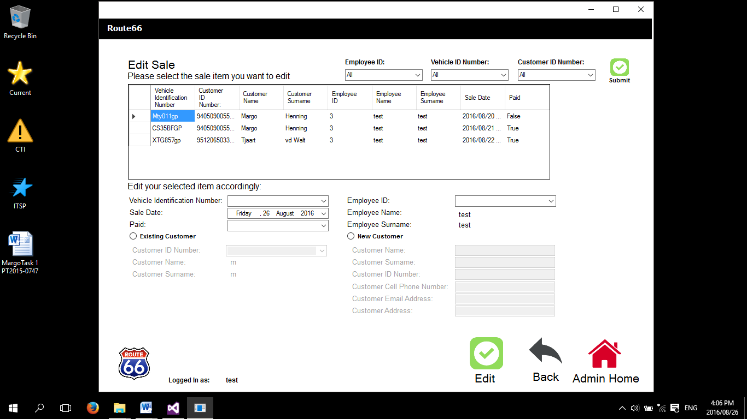

3.4.1 View Sales Page:

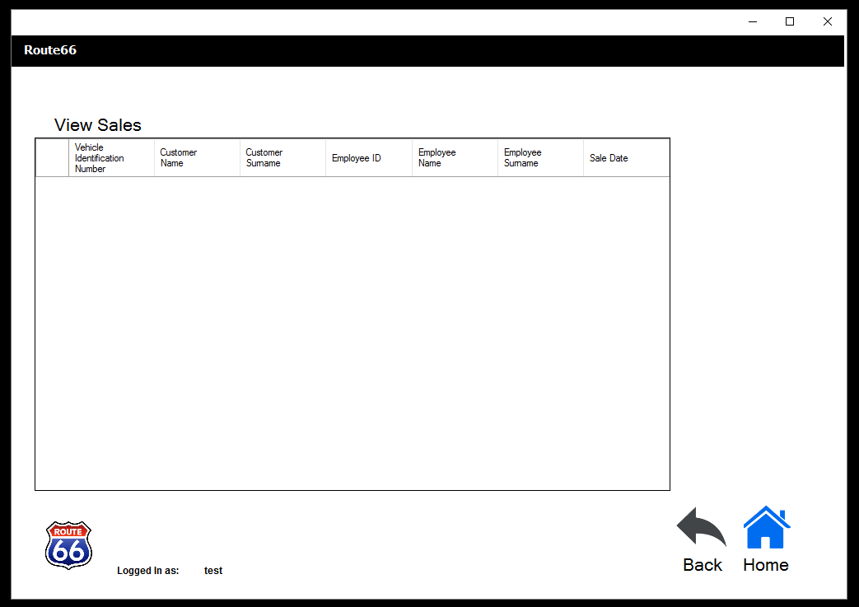

3.4.2 Make Sale Page:

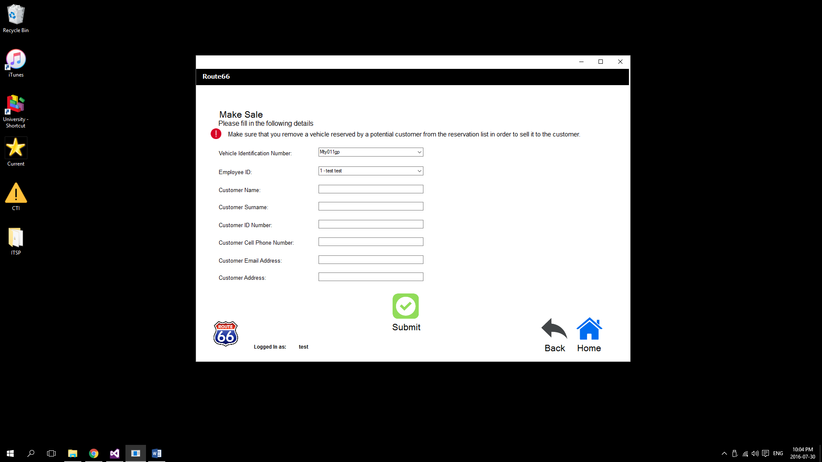

3.5 Customer Page:

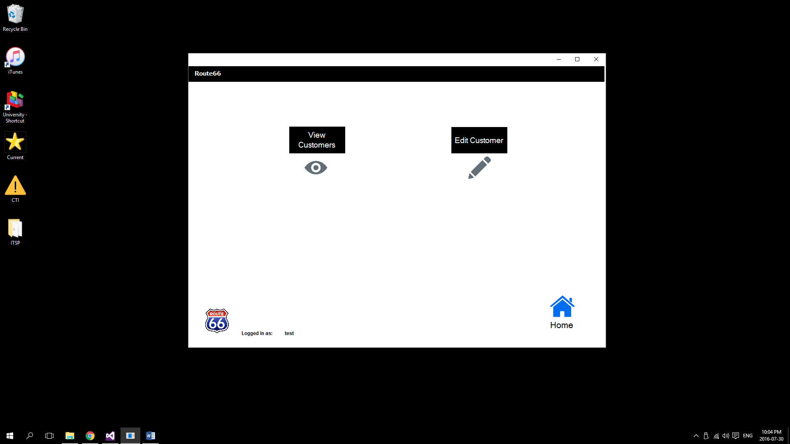

3.5.1 View Customers Page:

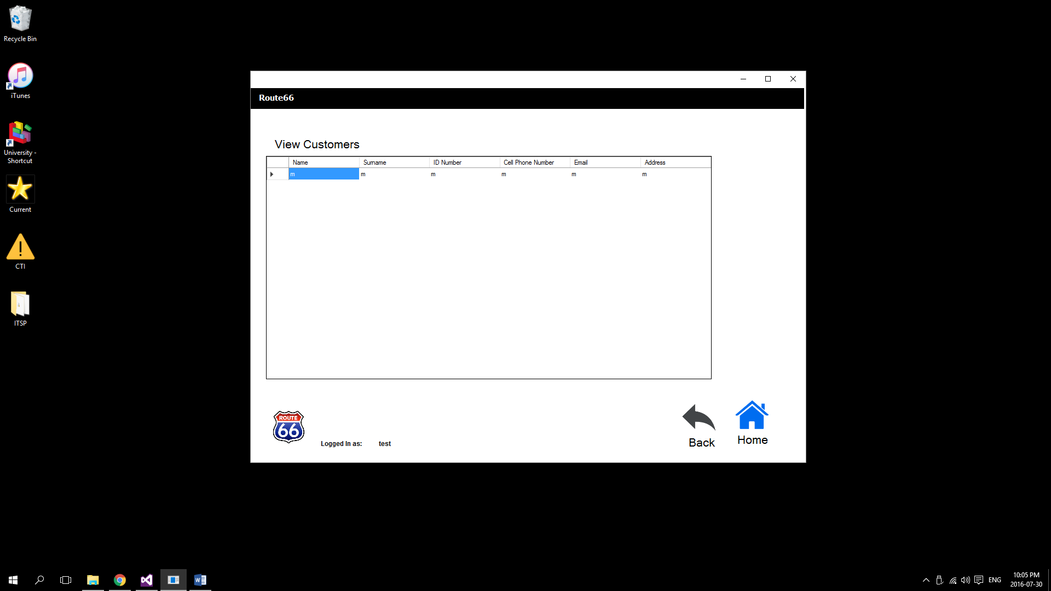

3.5.2 Edit Customers Page:

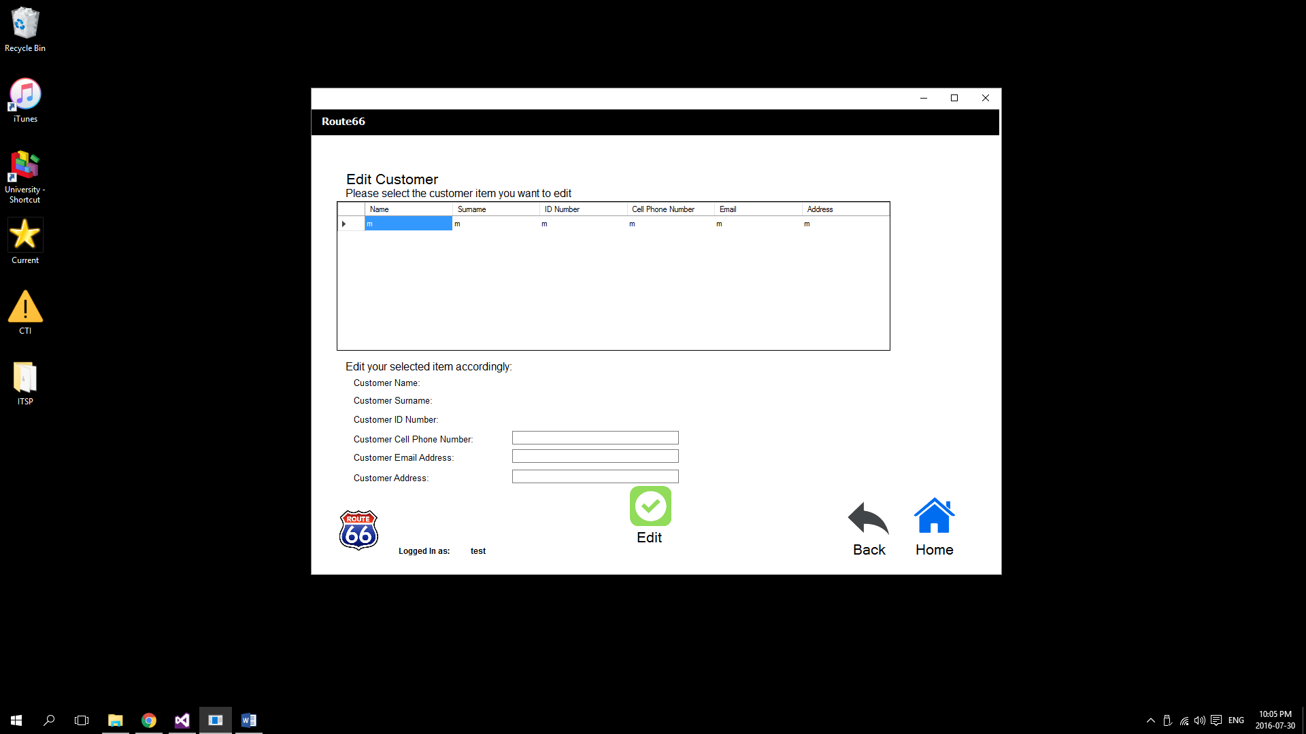

**4. Admin Pages:**

4.1 Admin Home Page:

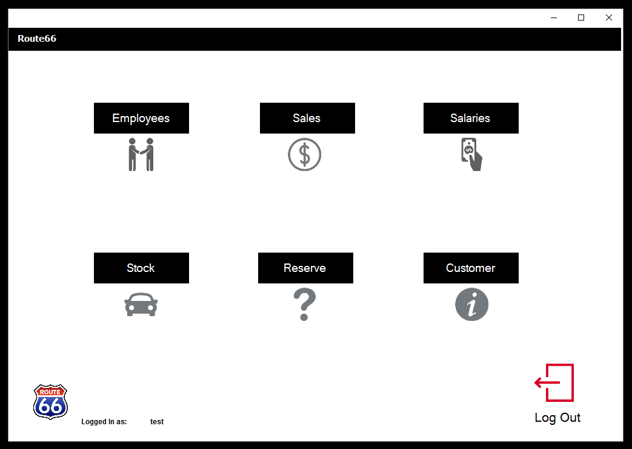

4.2 Employees Page:

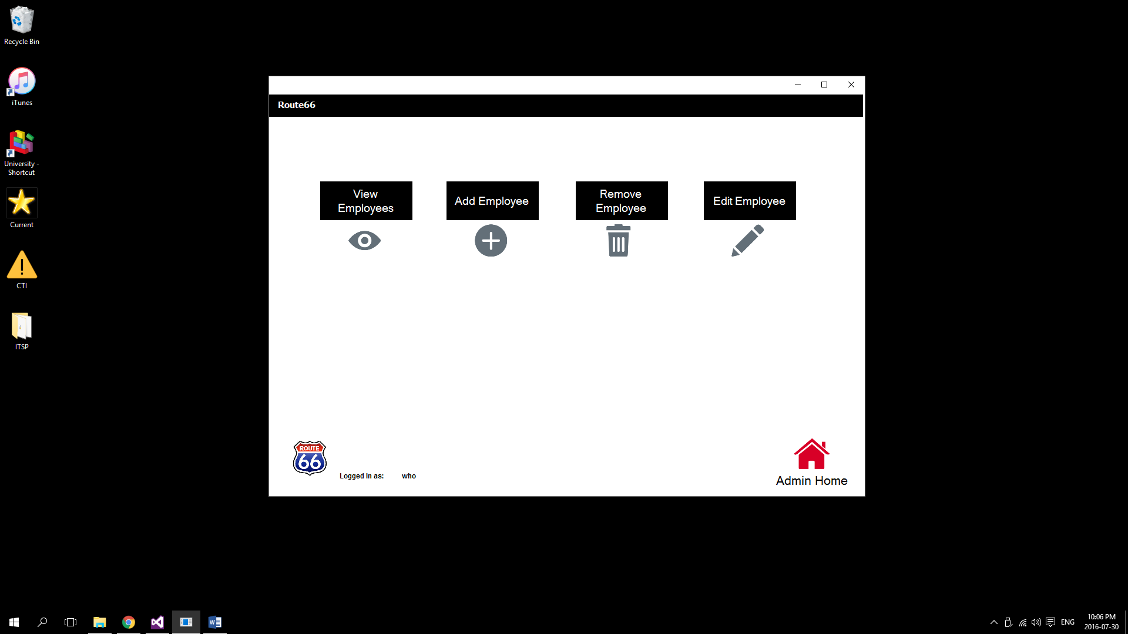

4.2.1 View Employees Page:

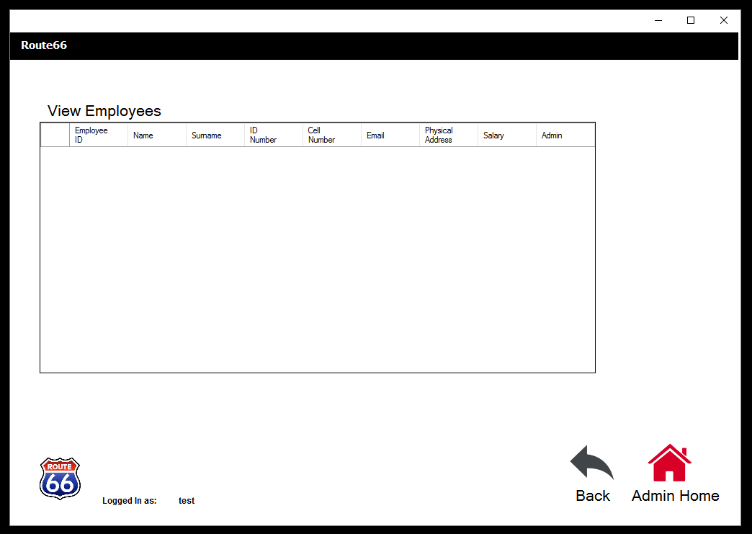

4.2.2 Add Employee Page:

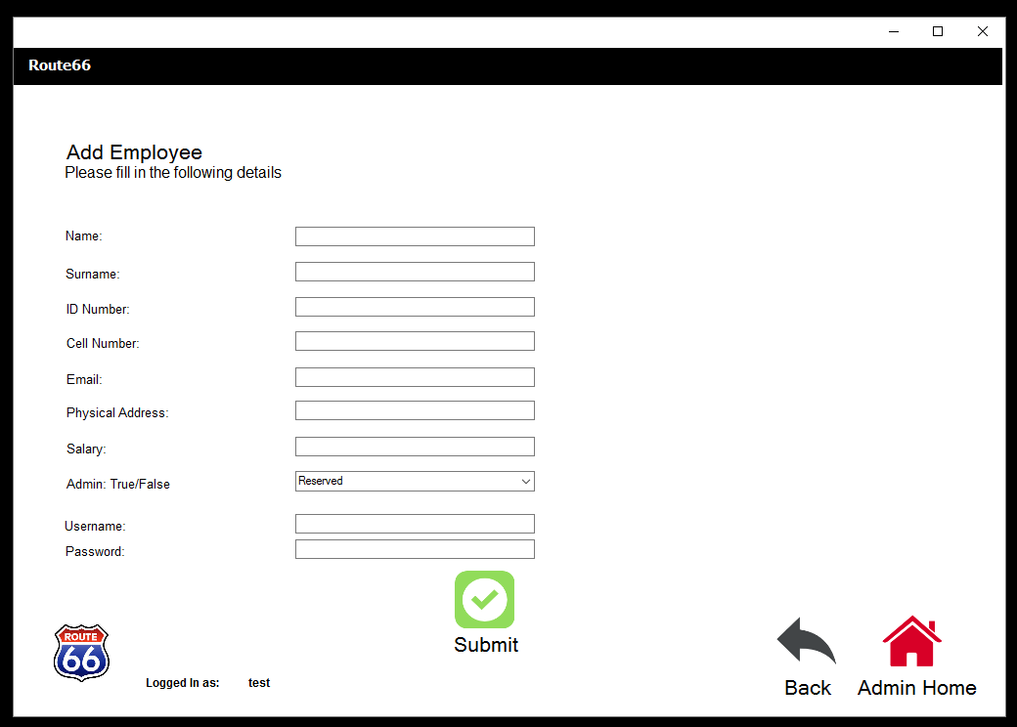

4.2.3 Remove Employee Page:

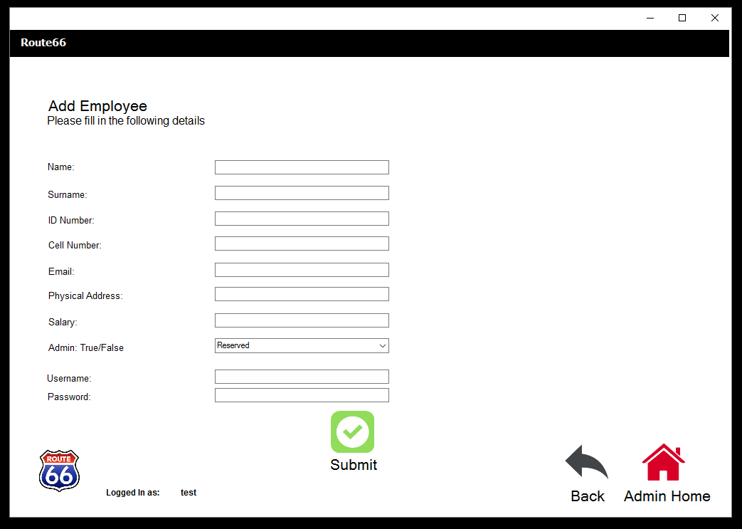

4.2.4 Edit employee page

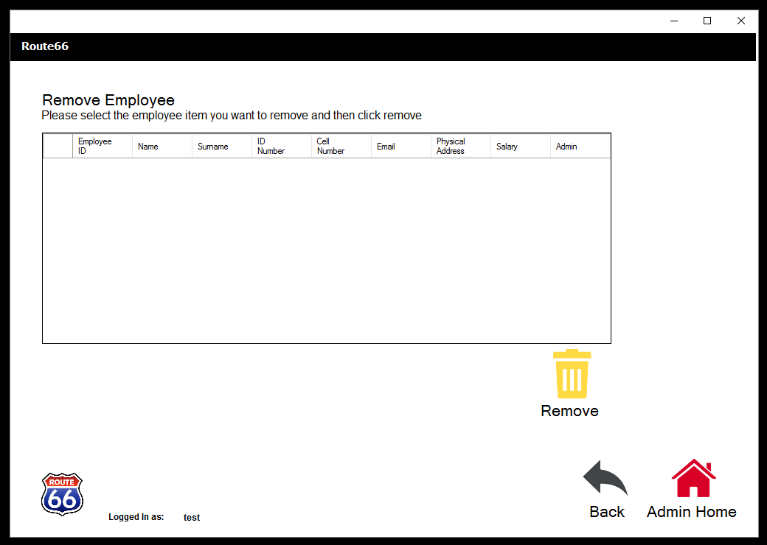

4.3 Sales Page:

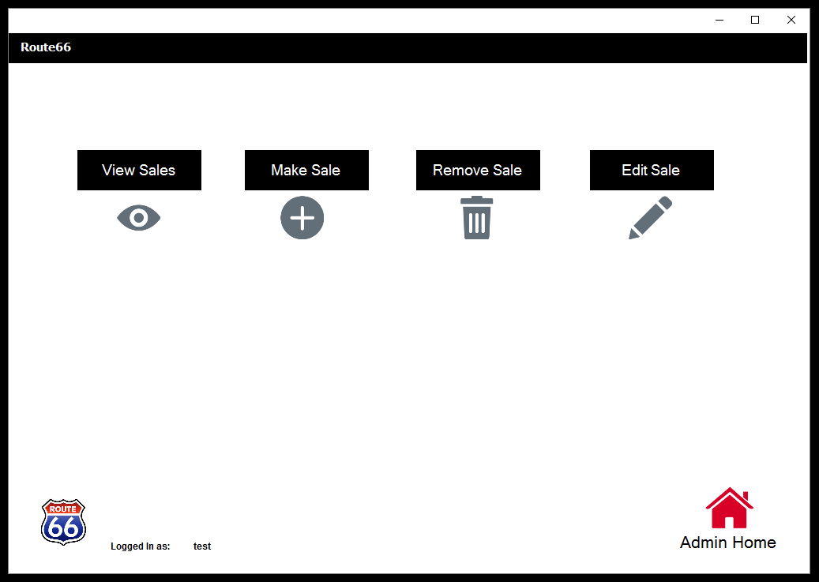

4.3.1 View Sales Page:

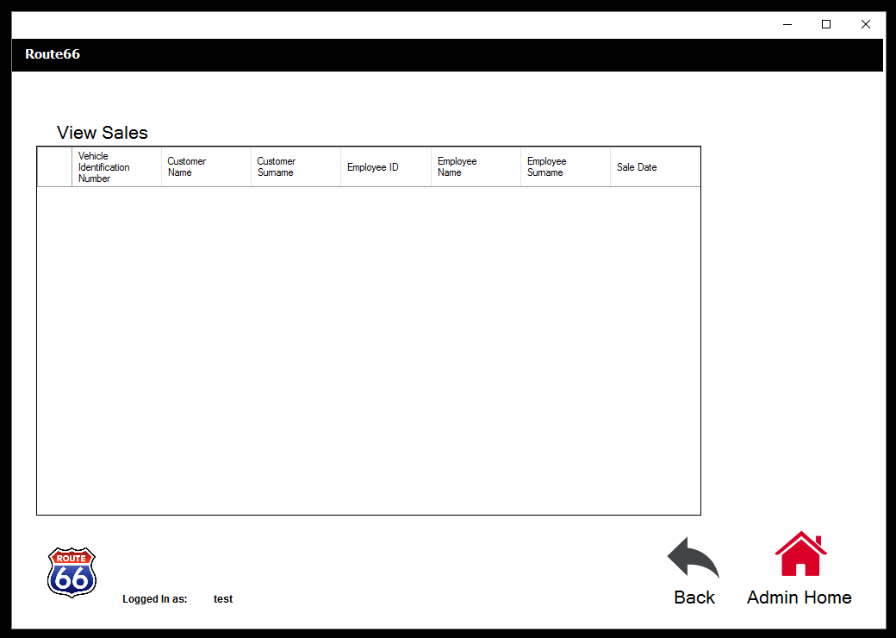

4.3.2 Make Sale Page:

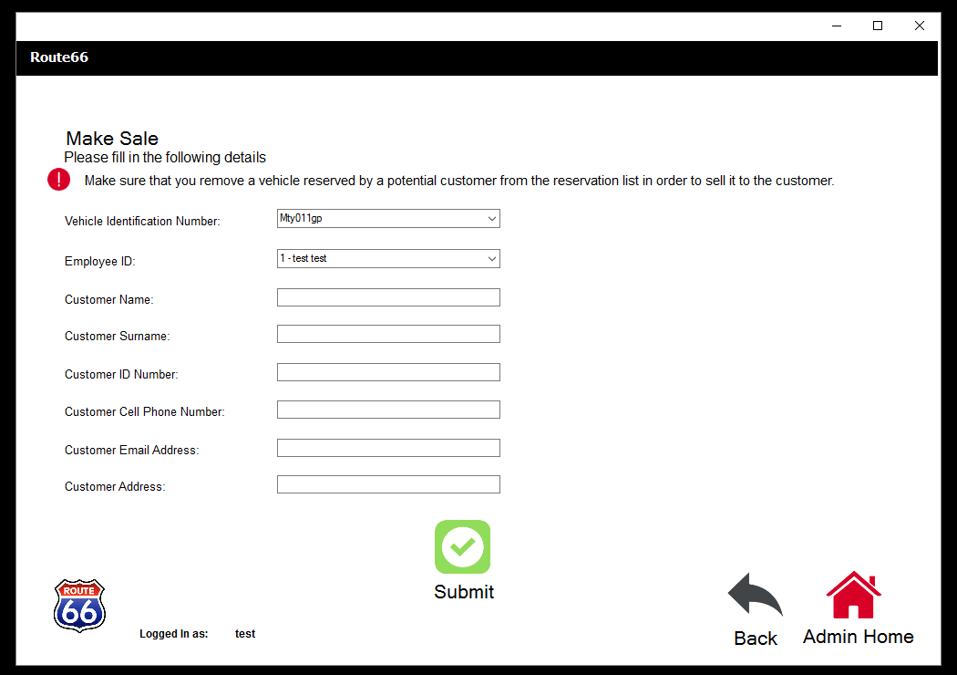

4.3.3 Remove Sale Page:

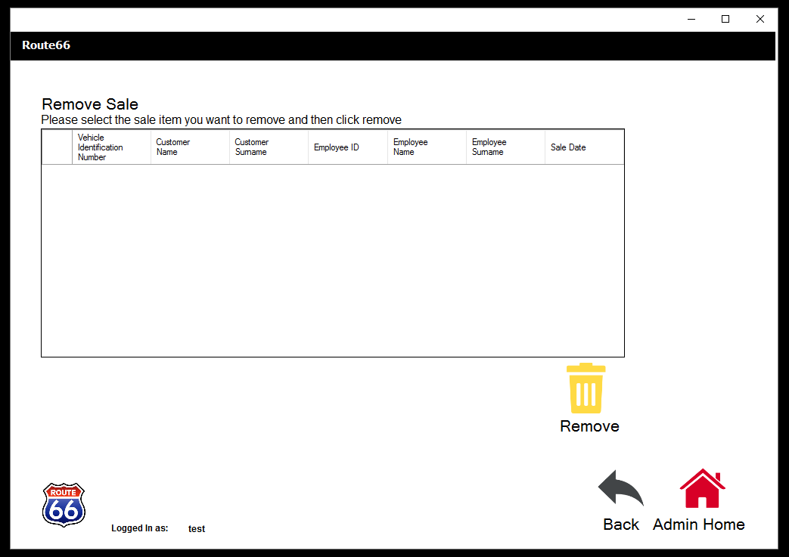

4.3.4 Edit Sale Page:

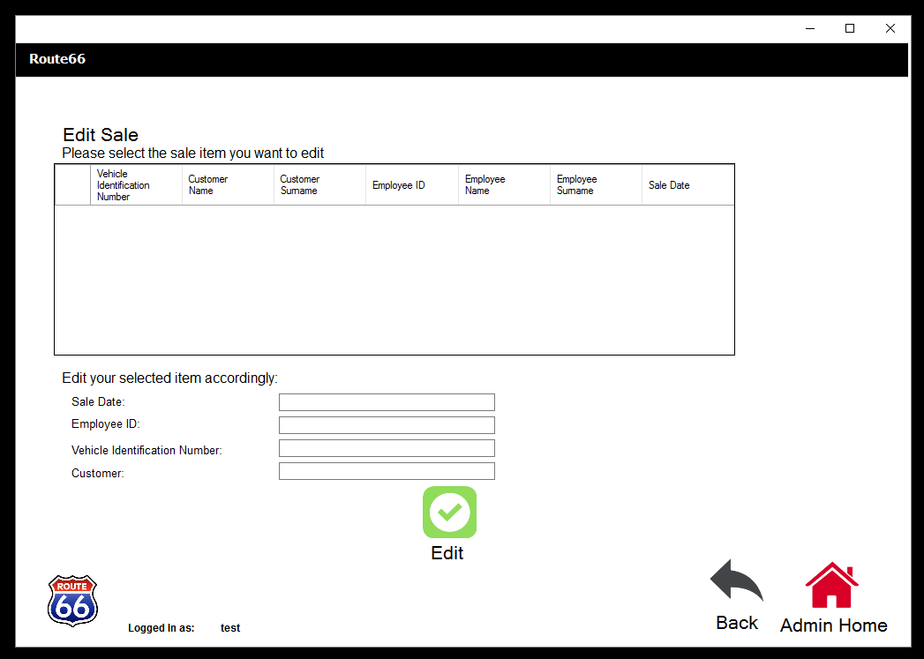

4.4 Salaries Page:

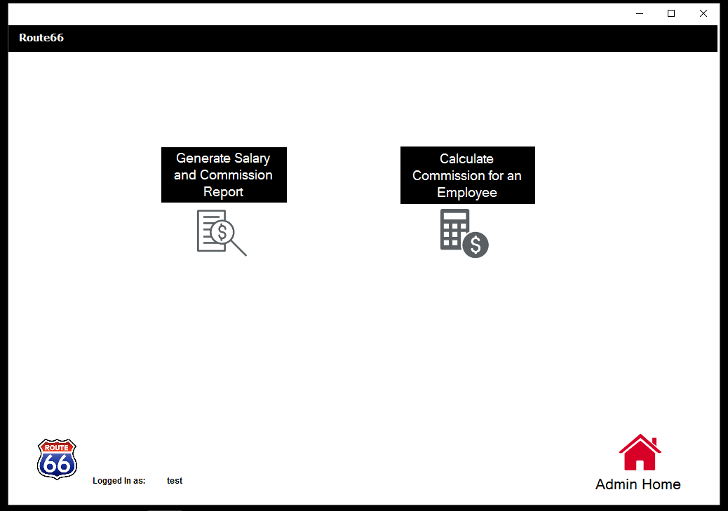

4.4.1 Generate Salary and Commission Report Page:

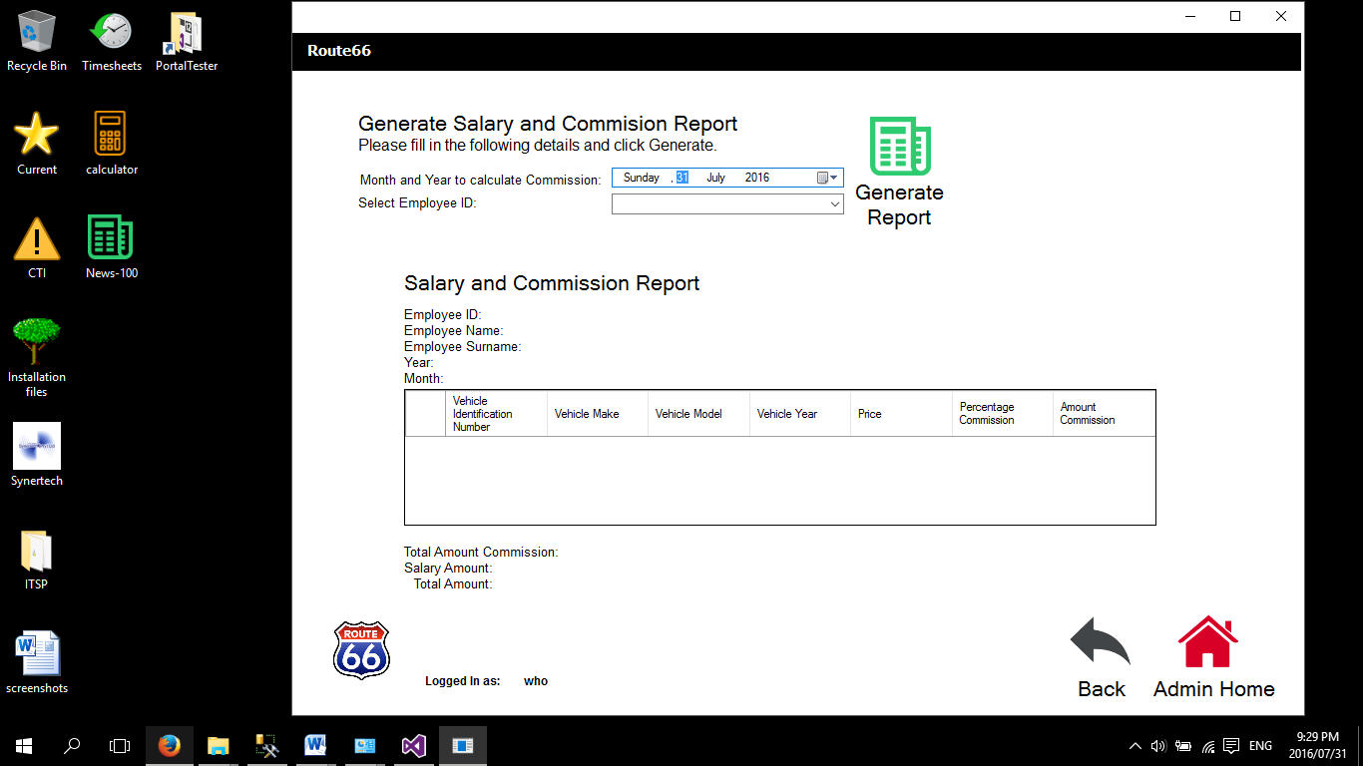

4.4.2 Calculate Commission for an Employee Page:

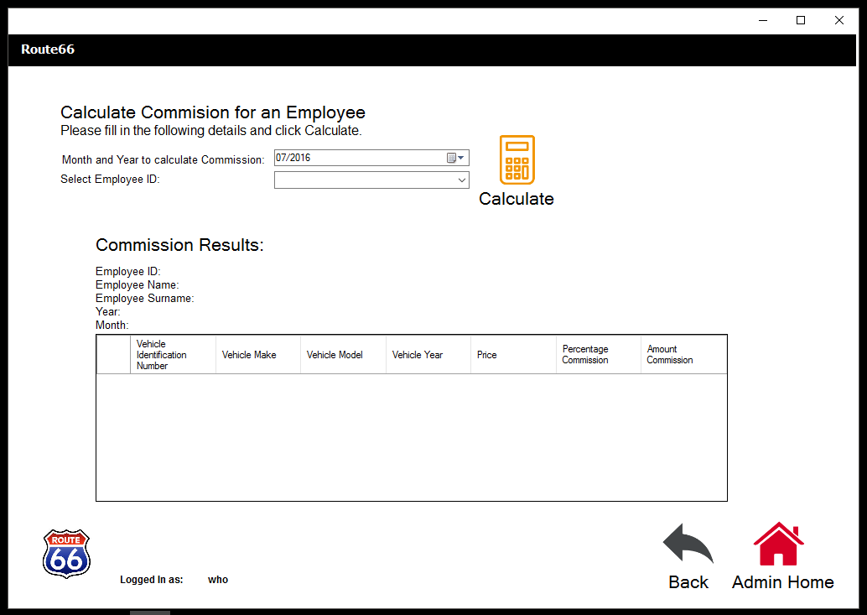

4.5 Stock Page:

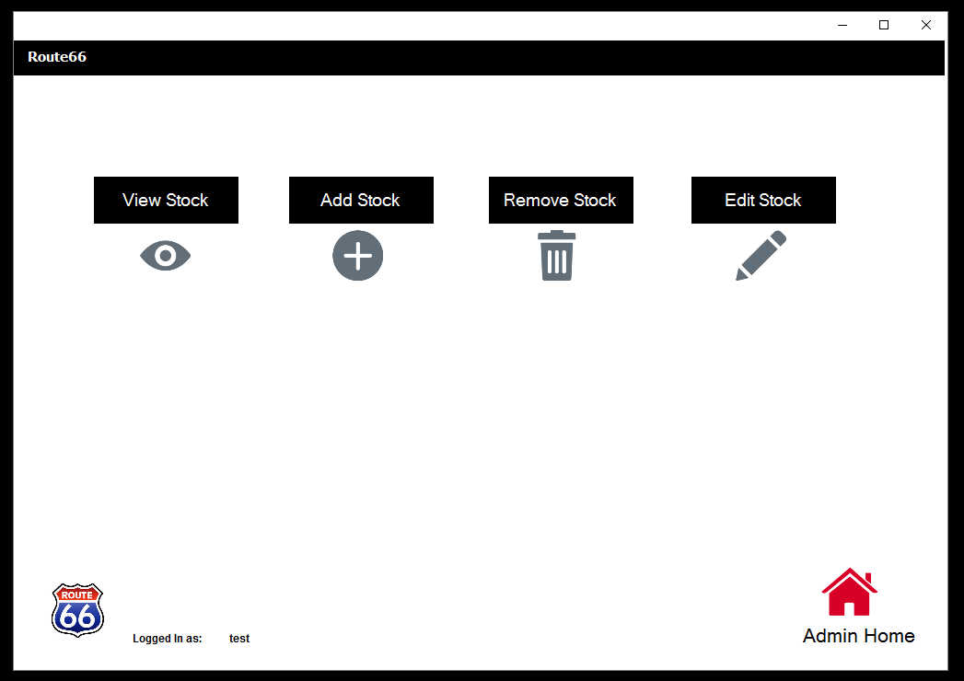

4.5.1 View Stock Page:

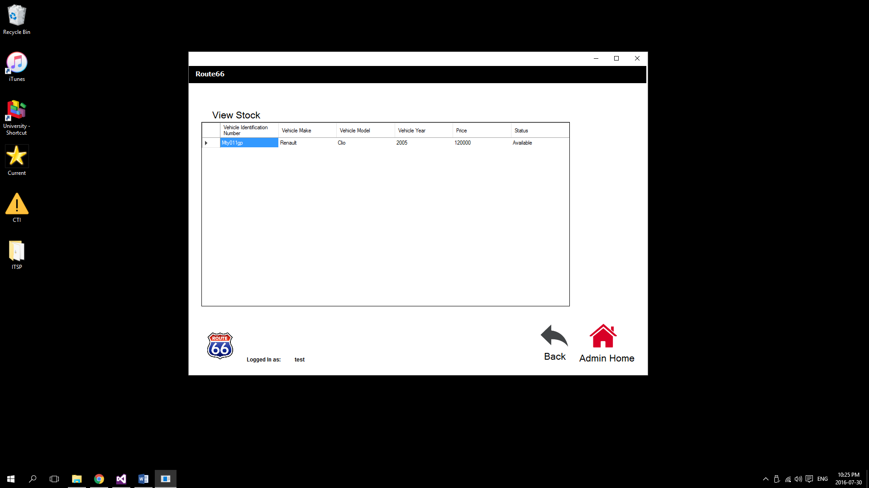

4.5.2 Add Stock Page:

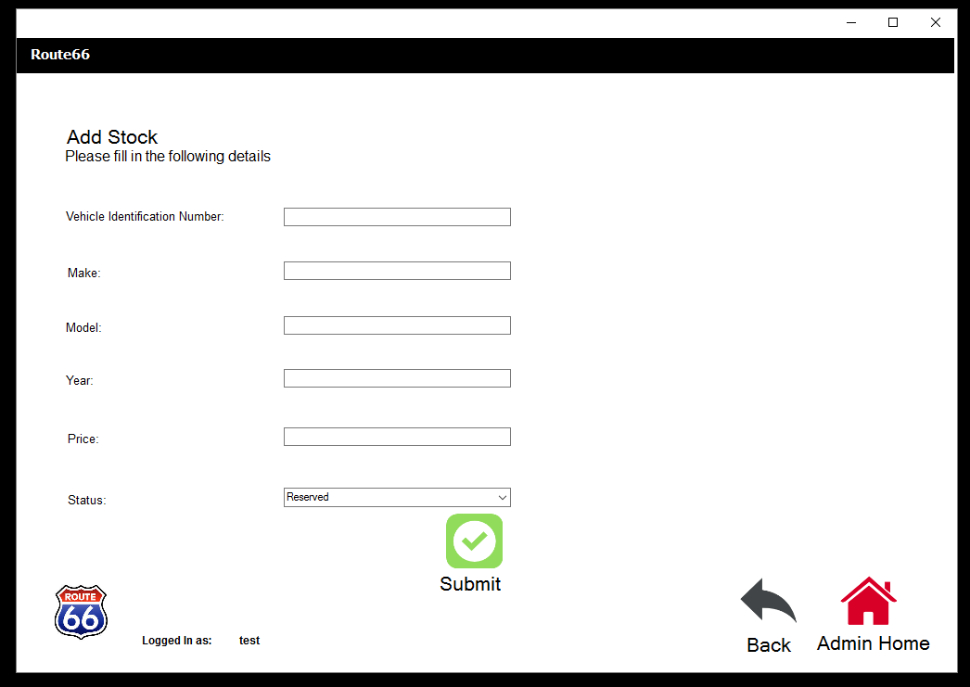

4.5.3 Remove Stock Page:

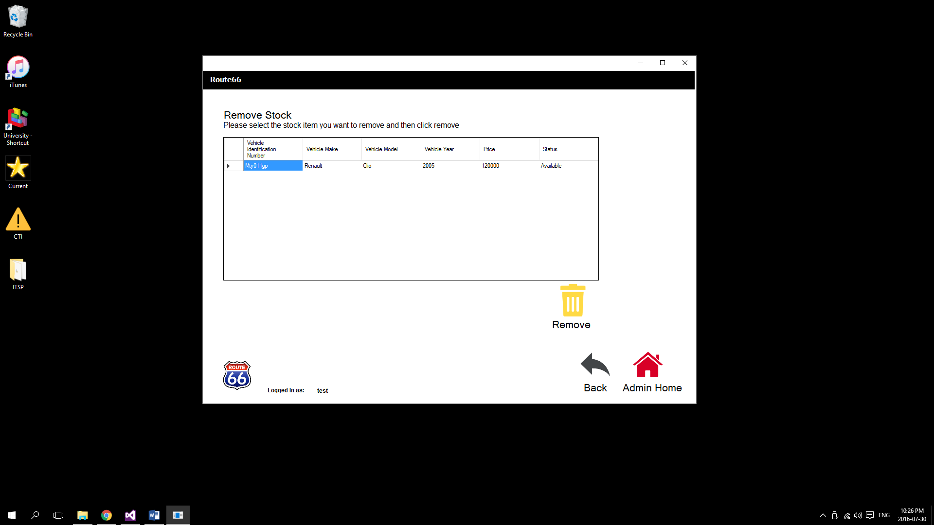

4.5.4 Edit Stock Page:

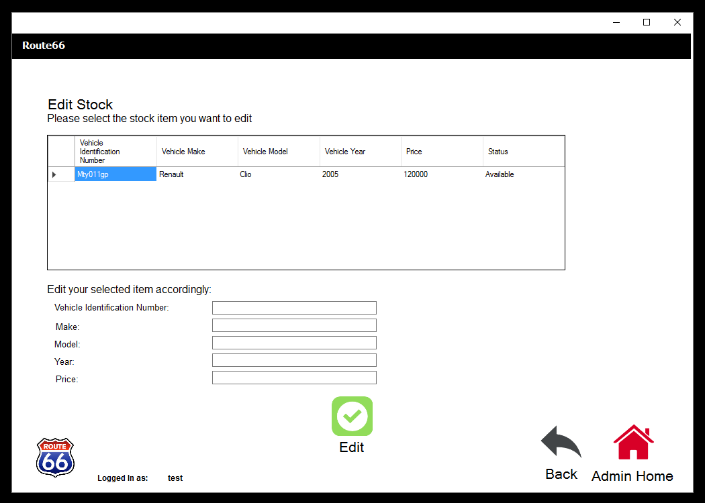

4.6 Reserve Page:

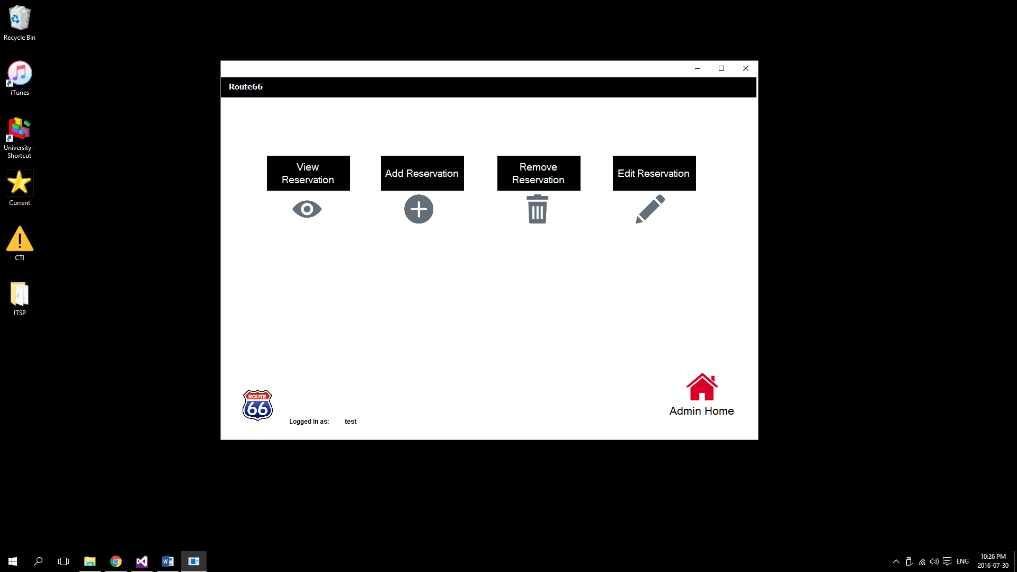

4.6.1 View Reservation Page:

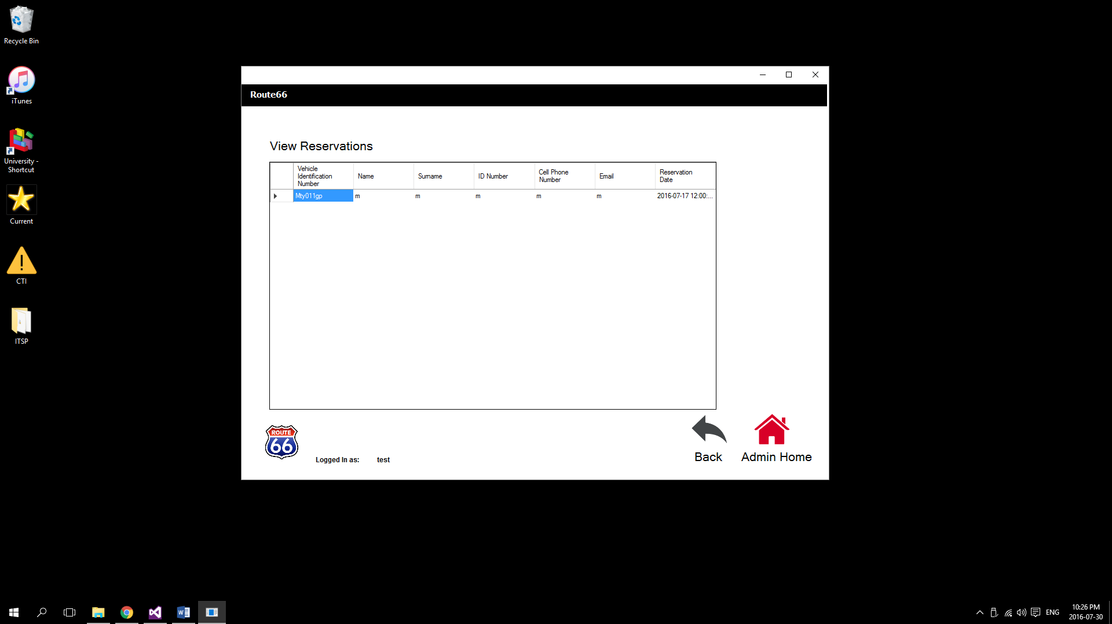

4.6.2 Add Reservation Page:

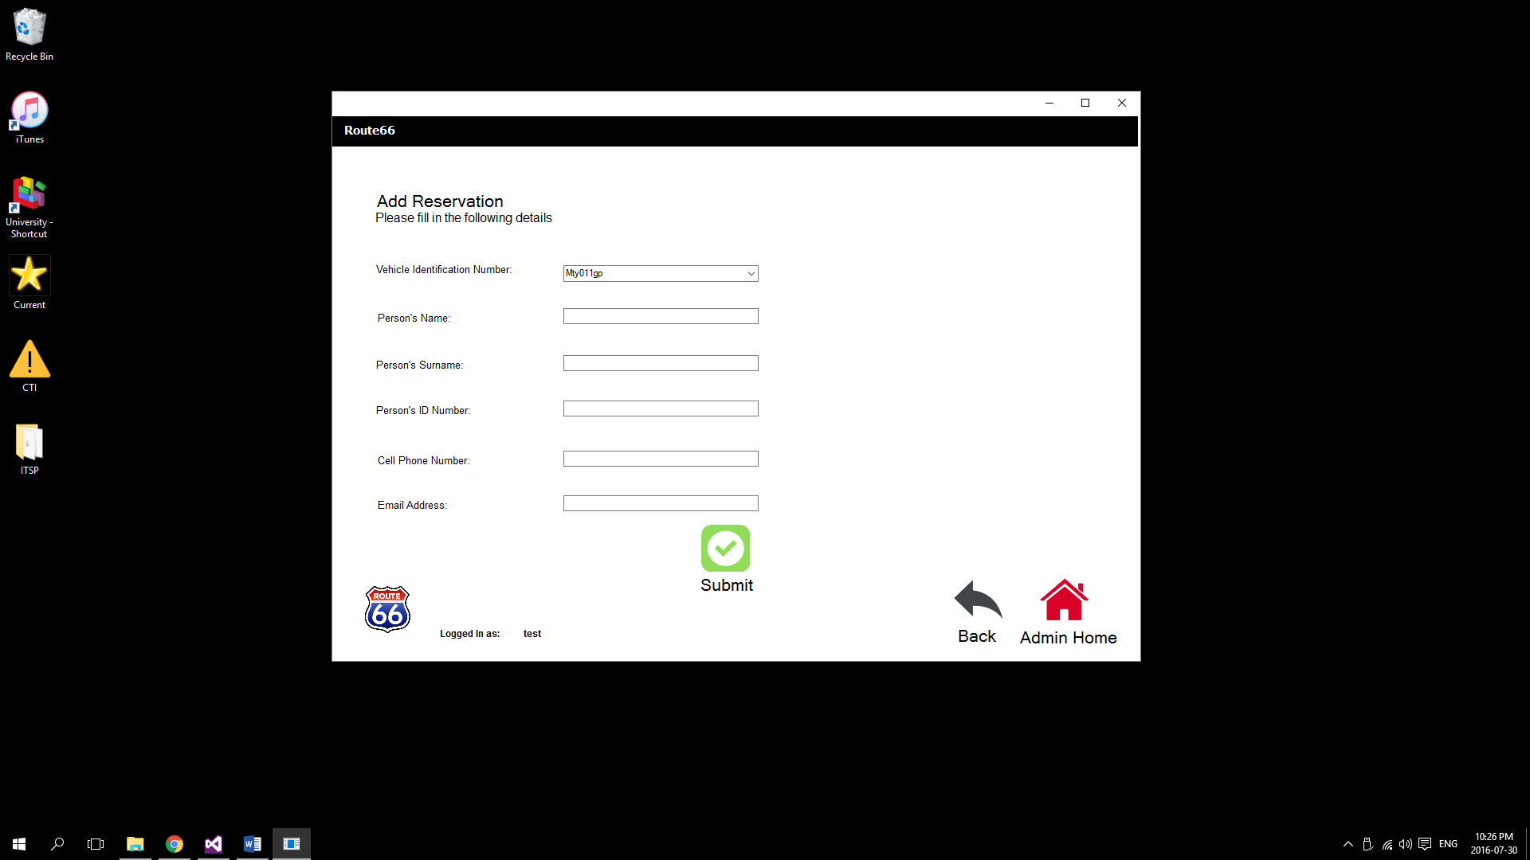

4.6.3 Remove Reservation Page:

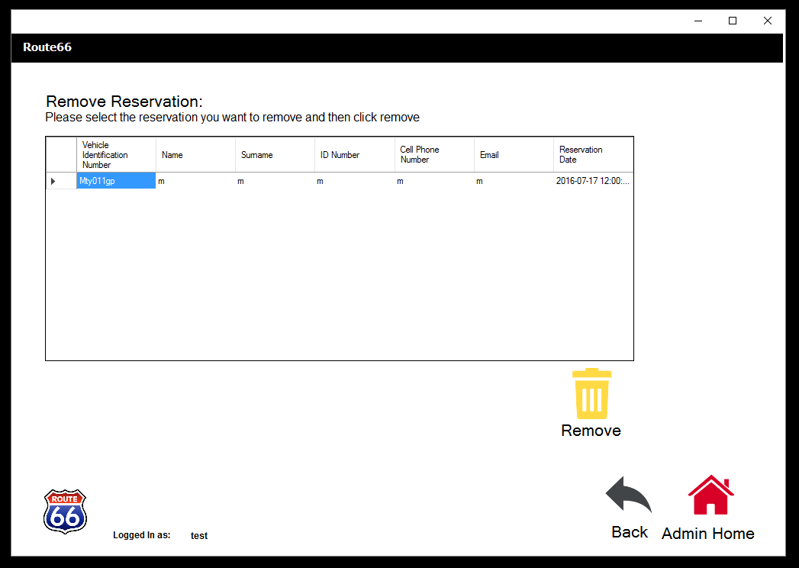

4.6.4 Edit Reservation:

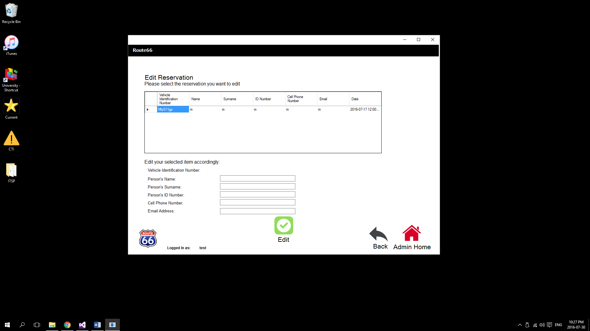

4.7 Customers Page:

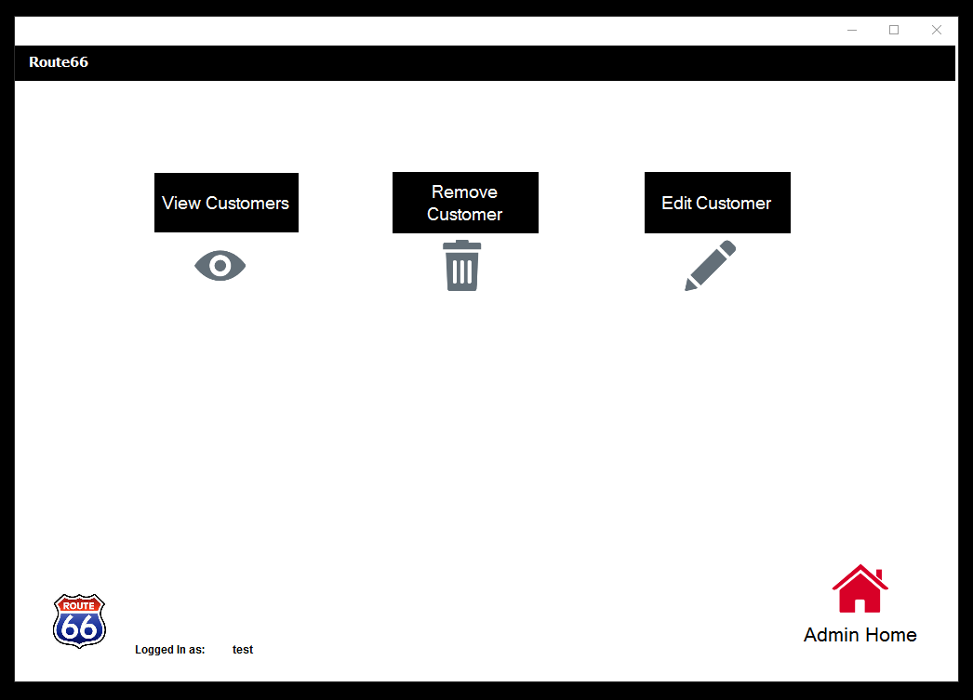

4.7.1 View Customers Page:

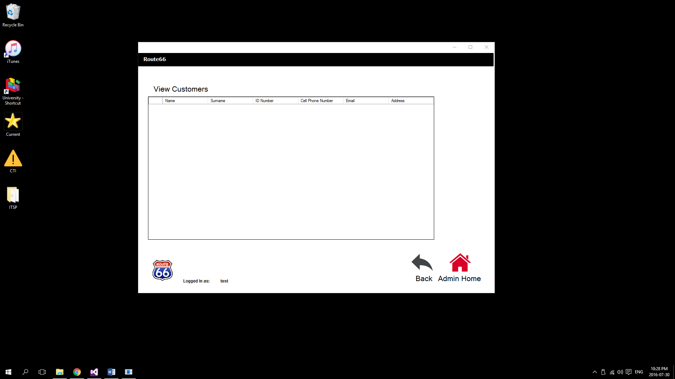

4.7.2 Remove Customer Page:

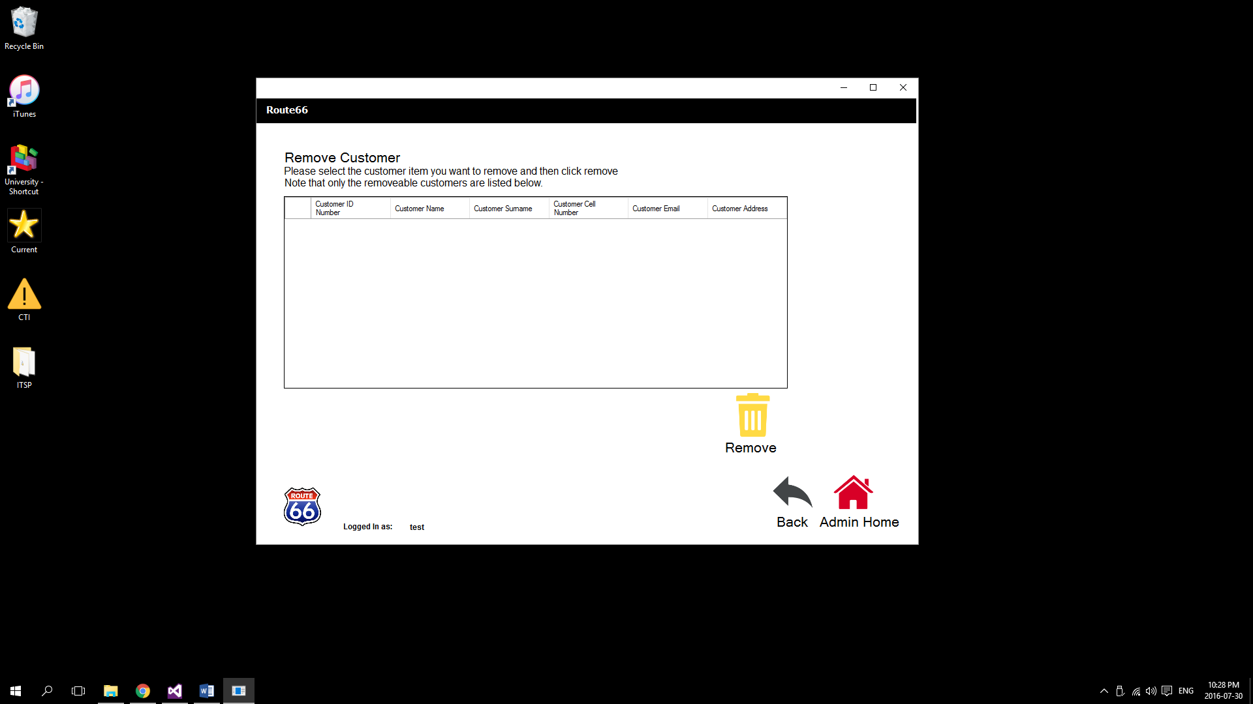

4.7.3 Edit Customer Page:

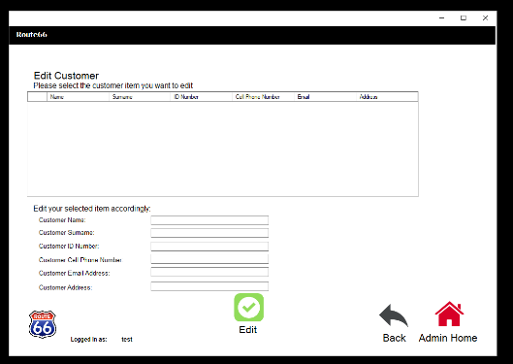

# Deliverable 4

## 5.1 Information Systems Testing

### 5.1.1 Testing results

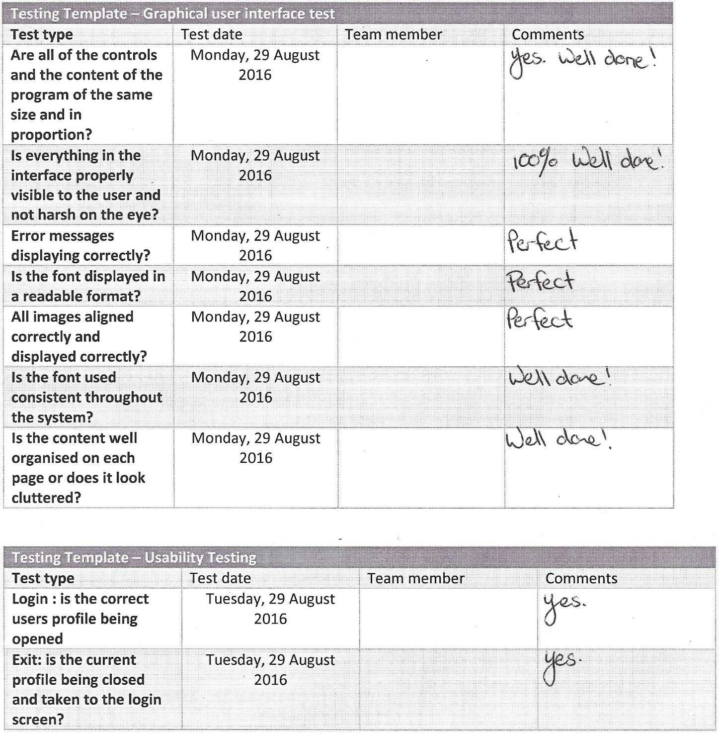

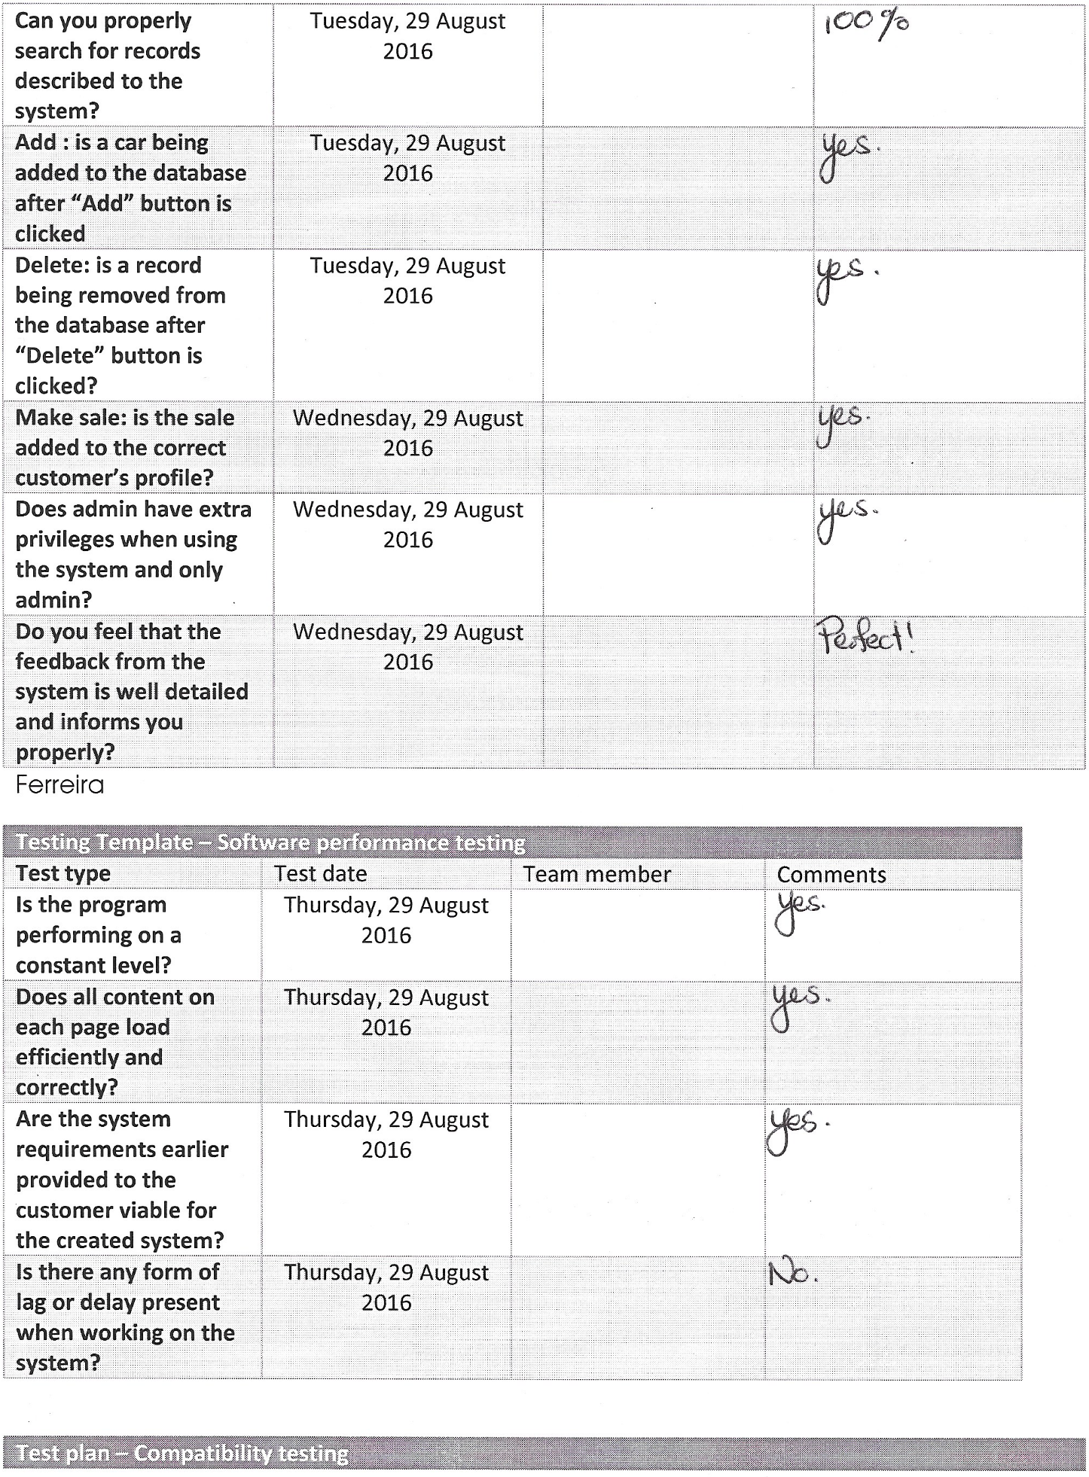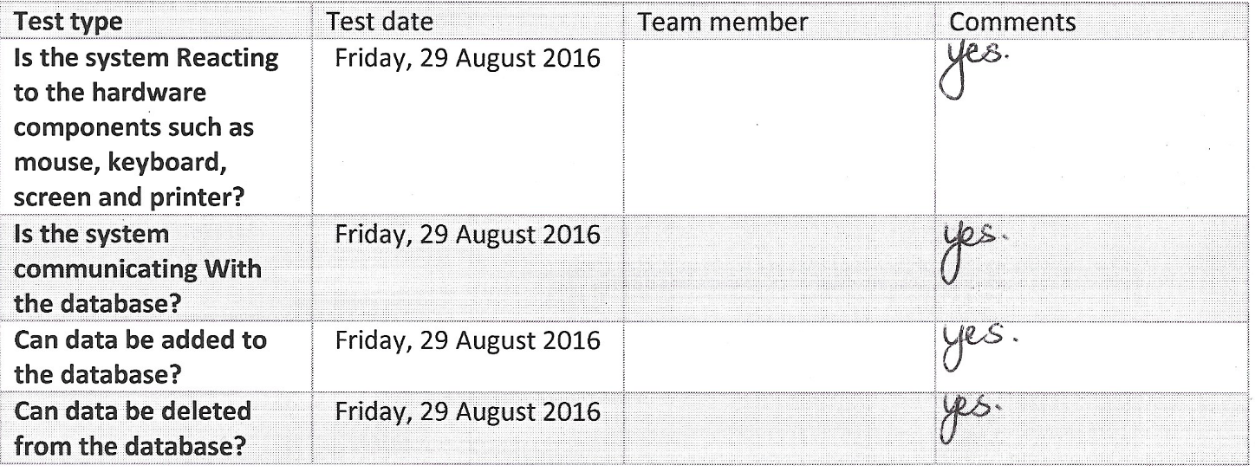

# Deliverable 5 – Evaluation Report

## 6.1 Introduction

In this report the evaluation of the system as well as the team members will be conducted. This report will indicate whether all the customer requirements have been met concerning the system functionality. We will also take a look at how the team performed during the duration of this project concerning conflict, time management, group performance etc. Each group members own experience during the project life time will also be described.

## 6.2 The final system and the customer’s requirements

We created a system for a car dealership which provides the functionality for everyday use by the normal employees as well as the admin employees.

The outcome of this system includes being able to add employees, add stock, add sales and make car reservations. The system also has functionality to view stock/employees, edit stock/employees, calculate commission, calculate salary and generate useful reports on sales made and system usage by employees.

The total outcome of the project is a successful and efficient working system which meets all the requirements of the customer. The customer did however propose a few slight changes in the system during the 1st systems testing appointment. We then made the changes according to the customer’s satisfaction.

## 6.3 Group dynamics and team collaboration

The software project group worked very well together. Very little to none conflict occurred as the group was understanding and supportive with each other. I believe that this group had the right amount of everything needed to form a competitive and intelligent group. Each group member more than once made great decisions to aid the group in the project.

Our group tried to listen to each members ideas they had for the project and incorporated it where we found fit to do so.

Regular group meetings at campus and of campus made for good communication between the group members. Internet Messaging or file sharing methods also helped the team to effectively communicate and share info. For example Whatsapp and email.

**6.4 Time management**

Unfortunately all group members did not have the same subjects enrolled than other members. Therefore it was a little difficult to schedule a meeting that would not affect other members in a bad way.

Luckily we pulled through and found time windows that worked best for all. We also scheduled about 5 or more meetings of campus in free time so that every team member could attend.

Working on a project like this while studying for tests and completing assignments was tough for the team. There were times when deadlines where almost not met. But luckily the group incorporated good time management and completed each deliverable on time.

Again Messaging platforms made it easier to communicate which saved a lot of time in the end.

The only improvement that might need to be made is that all members where not always on time for meetings or where not present. Although it happened rarely.

## 6.5 Lessons learnt

***Marius Minnie Pt2014-0007***

As project manager I learned that no team is perfect and one must accept that. But if a team works hard and encourage each other, we can get pretty close. Personally I improved management, leadership and communication skills during this project. I Learned to incorporate hard work and efficient methods into a project to achieve success and as close to perfection as possible. I learned to not only listen to self-instinct but use and incorporate others ideas and opinions into the project as well. And most importantly, to have fun. ☺

***Tiaan Ferreira Pt2012-0193***

I learnt that working in a group on certain content within the project we can master it rather than struggling as individuals. Supporting each other and deliver good work on time. I also learnt how to see the different perspectives each person have within the group. Lastly I learnt how to work with other people and how to communicate with them.

***Margo Henning Pt2015-0747***

During this project I learned how to listen to other team members and their opinions and how to communicate in an efficient way. I also learned the importance of not only gathering requirements, but understanding them thoroughly before jumping in and start solving problems. I learned that there is no shame in asking for help and support from your team members when completing a task. Most importantly I have learned to appreciate how my team mates think and the different approaches and skills they bring to the table to solve a problem.

***Devon Volkwyn Pt2014-0465***

I learnt that team work is essential when it comes to executing a project successfully. Planning is essential and helps to simplify tasks thus the workers can complete the tasks and finish the project efficiently. Organization is key to keeping the project running sufficiently. By creating achievable goals in the project it ups the motivation and keeps the project on schedule.

***Christiaan Tjaart Van der Walt Pt2014-0010***

I learned that when working as a group in a project you make better decisions that individuals because you can see how different perspectives , constructive deliberation, questioning and critical analysis can result in a better solution and in performance. I learned that communication in a very important aspect of group projects because you learn how to listen to other members and value from their opinions.

I learned that leadership is very important to unite a group to working towards a goal, keeping other members motivated, diffuse conflict and ultimately deliver success at the end of each deliverable/project.

## 6.6 Conclusion

Overall the team performed well in the development of the Route 66 Systems project. Each individual did what was needed and some individuals did a little more. This group developed many skills during this project that enhanced the performance of each individual. Team work and good communication is what kept the team going and which helped us to achieve the closest to perfection we can get.

# Deliverable 5 – User Manual

## Introduction

The system was created by MDMCT Processing. Route 66 will now be able to use an automated system to do their daily tasks that was previously done excel spread sheet based.

The system will allow employees to view all client information within the company database. The main functions of the automated system are to help employees and admin to create, alter and delete information within the database.

Users using the system will be divided into two classes namely:

Admin

Employees

This will be explained in the section called “How to log in”.

Login information will be given to each respective employee and their login rights.

***Support Contact Information:***

Tiaan Ferreira Tel: 0727896234

Marius Minnie Tel: 0603659842

Christiaan Van der Walt Tel: 0821697532

Margo Henning Tel: 0713672465

Devon Volkwyn Tel: 0846852698

## Getting started

## How to install

The system will be installed manually by MDMCT Processing. Users will have a shortcut created on their desktop, whereby they will only be double clicking on the shortcut to open the program.

## Instructions

## 7.1 How to log in

**Welcome Page:**

This is the home page where you as employee can login as admin or non admin user.

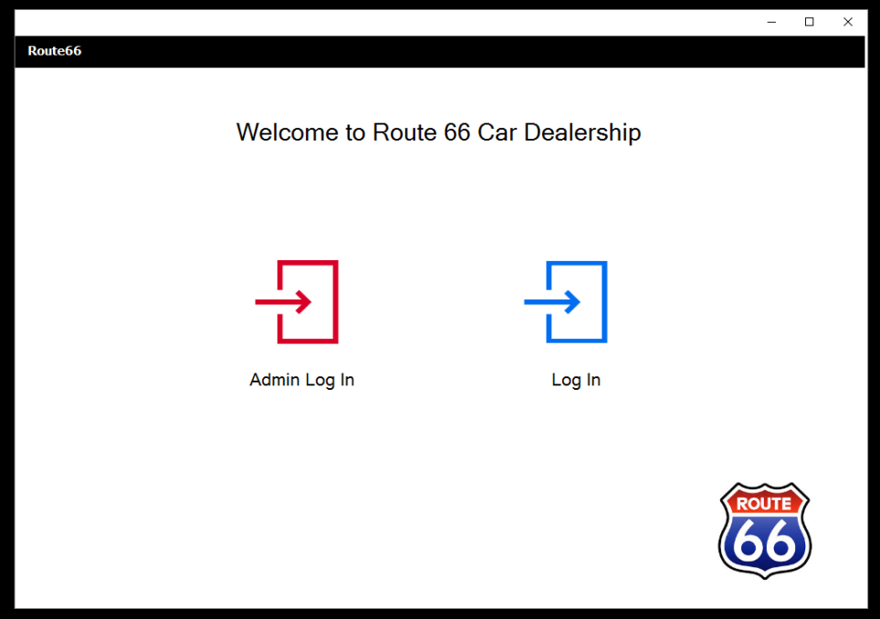

**Log In pages:**

**Note**: As admin you will be able to login by both sides of the system.

**Non Admin Log In page:**

Login with your given username and password and click on the submit icon to continue

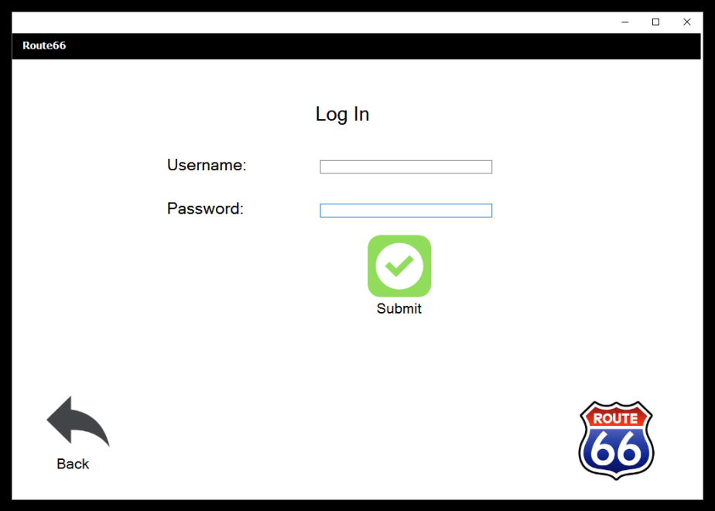

**Admin Log In page:**

Login with your given username and password and click on the submit icon to continue.

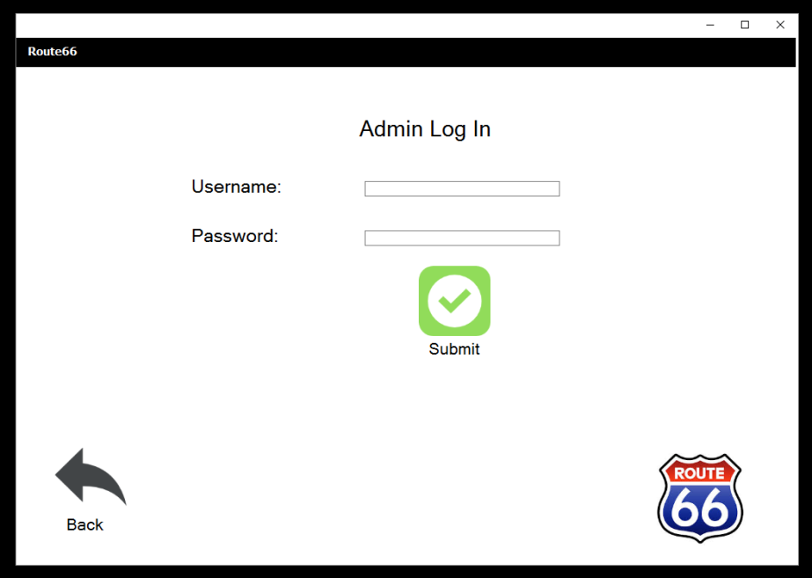

## 7.2 Non admin Employee Pages

### 7.2.1 Home Page:

After you have successfully logged into with your given details, you will be redirected to the home page where you have your four main options namely: Stock, Reserve, Sale and Customer.



**Stock Page:**

When you clicked on the “View Stock” button on the home page you have been redirected to the Stock page where you also have four options namely: View Stock, Add stock, Remove Stock and Edit Stock.



**View Stock Page:**

When you clicked on the “View Stock” button from the Stock page you will see a similar screen where you will be able to view all stock that is in the database of Route 66.



**Add Stock Page**

When you clicked on the “Add Stock” button from the Stock page, you will be able to add details of a new car, the following details within the page is a must, not one field can be left open. When you filled all the fields correctly in you can click on the submit button to add the new vehicle.



**Remove Stock Page:**

When you clicked on the “Remove Stock” button from the Stock page, you will be able to remove stock from the Route 66 database. Simply click on the desired car you want to remove once it is highlighted click on the Remove icon to remove it successfully.



**Edit Stock Page:**

When you clicked on the “Edit Stock” button from the Stock page, you will be able to edit current stock within the Route 66 database. Select the desired information you want to edit, when highlighted edit the current details then click on the edit icon to edit the information successfully.



### 7.2.2 Reserve Page:

When you clicked on the “Reserve” button on the home page you have been redirected to the Reserve page where you also have four options namely: View Reservation, Add Reservation, Remove Reservation and Edit Reservation.



**View Reservation:**

When you clicked on the “View Reservation” button from the Reserve page, you will be able to view all the reservation that was made, since the page was lastly refreshed.



**Add Reservation:**

NOTE: You must enter a vehicle identification that already exists within the current stock

When you clicked on the “Add Reservation” button from the Reserve page, you will be able to add details of a new reservation, the following details within the page is a must, not one field can be left open. When you filled all the fields correctly in you can click on the submit button to add the new reservation details.



**Remove Reservation:**

When you clicked on the “Remove Reservation” button from the Reserve page, you will be able to remove reservations from the Route 66 database. Simply click on the desired reservation you want to remove once it is highlighted click on the Remove icon to remove it successfully.



**Edit Reservation:**

When you clicked on the “Edit Reservation” button from the Reserve page, you will be able to edit current reservations within the Route 66 database. Select the desired information you want to edit, when highlighted edit the current details then click on the edit icon to edit the information successfully.



### 7.2.3 Sale Page:

When you clicked on the “Sale” button on the home page you have been redirected to the Sale page where you have 2 options namely: View Sale and Make Sale.



**Make Sale Page:**

NOTE: Skip figure Admin if you are logged in as a non admin user.

**Make Sale (Admin)**

You as admin will be able to make a sale, while making the sale you will also be able to create a new customer or make the sale to an existing customer. Choose the vehicle identification number form the drop down box, select employee ID and select whether the customer did pay. Click on the submit icon to make it a successful sale.



Figure: Admin

**Make Sale (Non Admin)**

As a non admin you will be able to select the vehicle you want to edit and then select the vehicle identification number from the drop down list, enter your employee ID. Select if the customer is existing or new, if new enter his/her details and then click on the edit button to successfully edit the sale.



Figure: Non Admin

**Make Sale Page:**

This is where you can make a sale. Enter the vehicle identification number. The following details within the page are a must, not one field can be left open. When you filled all the fields correctly in you can click on the submit button to add the new reservation details.



**View Sales Page:**

When you clicked on the “View Sales” button from the Sales page, you will be able to view all the sales that were made, since the page was lastly refreshed.



### 7.2.4 Customer Page:

When you clicked on the “Customer” button on the home page you have been redirected to the Customer page where you have 2 options namely: View Customers and Edit Customers.



**View Customers Page:**

When you clicked on the “View Customers” button from the Customers page, you will be able to view all the Customers that are currently registered, since the page was lastly refreshed.



**Edit Customers Page:**

NOTE: There are some fields disabled that only admin users can edit. Talk to any managers or the CEO if you desire to edit those fields.

When you clicked on the “Edit Customers” button from the Customers page, you will be able to edit current customers within the Route 66 database. Select the desired information you want to edit, when highlighted edit the current details then click on the edit icon to edit the information successfully.



## 7.3 Admin Pages:

### 7.3.1 Admin Home Page:

After you have successfully logged into with your given details, you will be redirected to the home page where you have your six main options namely: Employees, Sales, Salaries, Stock, Reserve and Customer.



**Employees Page:**

When you clicked on the “Employees” button on the home page you have been redirected to the Employees page where you also have four options namely: View Employees, Add Employee, Remove Employee and Edit Employee.



**View Employees Page:**

When you clicked on the “View Employees” button from the Employee page, you will be able to view all the Employees that are currently working at Route 66, since the page was lastly refreshed.



**Add Employee Page:**

When you clicked on the “Add Employee” button from the Employee page, you will be able to add details of the new Employee, the following details within the page is a must, not one field can be left open. When you filled all the fields correctly in you can click on the submit button to add the new employee details.



**Remove Employee Page:**

When you clicked on the “Remove Employee” button from the Employee page, you will be able to remove employee from the Route 66 database. Simply click on the desired employee you want to remove once it is highlighted click on the Remove icon to remove the employee successfully.



**Edit employee page:**

When you clicked on the “Edit Employee” button from the Employee page, you will be able to edit current Employees within the Route 66 database. Select the desired information you want to edit, when highlighted edit the current details then click on the edit icon to edit the information successfully.

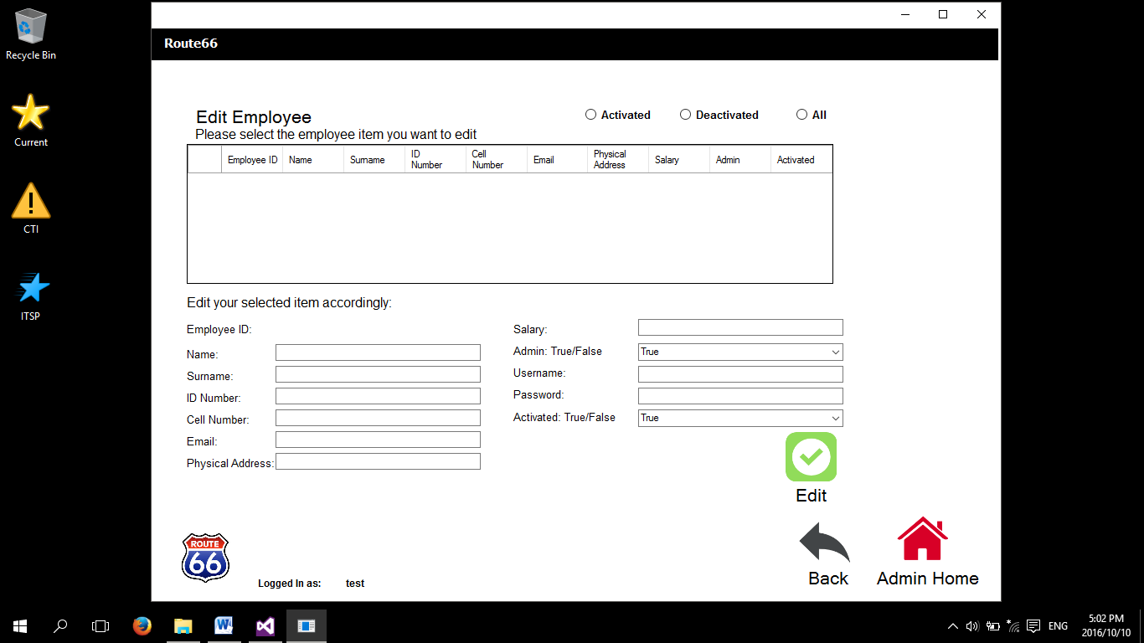

### 7.3.2 Sales Page:

When you clicked on the “Sales” button on the home page you have been redirected to the Sales page where you also have four options namely: View Sales, Add Sale, Remove Sale and Edit Sale.



**View Sales Page:**

When you clicked on the “View Sales” button from the Sales page, you will be able to view all the Sales that are currently active at Route 66, since the page was lastly refreshed.



**Make Sale Page:**

While making the sale you will be able to create a new customer or make the sale to an existing customer. Choose the vehicle identification number form the drop down box, select employee ID. The following details within the page are a must, not one field can be left open. When you filled all the fields correctly in you can click on the submit button to add the new sale details. Click on the submit icon to make it a successful sale.



**Remove Sale Page:**

When you clicked on the “Remove Sale” button from the Sale page, you will be able to remove Sale from the Route 66 database. Simply click on the desired Sale you want to remove once it is highlighted click on the Remove icon to remove the Sale successfully.



**Edit Sale Page:**

When you clicked on the “Edit Sale” button from the Sale page, you will be able to edit current Sales within the Route 66 database. Select the desired information you want to edit, when highlighted edit the current details then click on the edit icon to edit the information successfully.



### 7.3.3 Salaries Page:

When you clicked on the “Salaries” button on the home page you have been redirected to the Salaries page where you have two options namely: Generate Salary and Commission Report and Calculate Commission for an Employee.



**Generate Salary and Commission Report Page:**

When you clicked on the “Generate Salary and Commission Report” button from the Salaries page, you will be able to generate a report that you can view the commission reports of each employee; you can generate these reports according by Month and Year. Simply select the employee ID and order by month and year then click on the icon Generate Report to make the commission calculation whereby you can export to Excel spread sheet.



**Calculate Commission for an Employee Page:**

When you clicked on the “Calculate Commission for an Employee” button from the Salaries page, you will be able to calculate each employee Commission Result according to month and year. To do this simply click on the Calculate icon after you have selected the desired Employee ID and month and year you want to calculate the results will be shown in the column below the Commission Results.



### 7.3.4 Stock Page:

When you clicked on the “Stock” button on the home page you have been redirected to the Stock page where you have four options namely: View Stock, Add Stock, Remove Stock and Edit Stock.



**View Stock Page:**

When you clicked on the “View Stock” button from the Stock page you will see a similar screen where you will be able to view all stock that is in the database of Route 66.



**Add Stock Page:**

When you clicked on the “Add Stock” button from the Stock page, you will be able to add details of a new car, the following details within the page is a must, not one field can be left open. When you filled all the fields correctly in you can click on the submit button to add the new vehicle.



**Remove Stock Page:**

When you clicked on the “Remove Stock” button from the Stock page, you will be able to remove stock from the Route 66 database. Simply click on the desired car you want to remove once it is highlighted click on the Remove icon to remove it successfully.



**Edit Stock Page:**

When you clicked on the “Edit Stock” button from the Stock page, you will be able to edit current stock within the Route 66 database. Select the desired information you want to edit, when highlighted edit the current details then click on the edit icon to edit the information successfully.



### 7.3.5 Reserve Page:

When you clicked on the “Reserve” button on the home page you have been redirected to the Reserve page where you also have four options namely: View Reservation, Add Reservation, Remove Reservation and Edit Reservation.



**View Reservation Page:**

When you clicked on the “View Reservation” button from the Reserve page, you will be able to view all the reservation that was made, since the page was lastly refreshed.



**Add Reservation Page:**

NOTE: You must enter a vehicle identification that already exists within the current stock

When you clicked on the “Add Reservation” button from the Reserve page, you will be able to add details of a new reservation, the following details within the page is a must, not one field can be left open. When you filled all the fields correctly in you can click on the submit button to add the new reservation details.



**Remove Reservation Page:**

When you clicked on the “Remove Reservation” button from the Reserve page, you will be able to remove reservations from the Route 66 database. Simply click on the desired reservation you want to remove once it is highlighted click on the Remove icon to remove it successfully.



**Edit Reservation:**

When you clicked on the “Edit Reservation” button from the Reserve page, you will be able to edit current reservations within the Route 66 database. Select the desired information you want to edit, when highlighted edit the current details then click on the edit icon to edit the information successfully.



### 7.3.6 Customers Page:

When you clicked on the “Customer” button on the home page you have been redirected to the Customer page where you have three options namely: View Customers, Remove Customers and Edit Customers.



**View Customers Page:**

When you clicked on the “View Customers” button from the Customers page, you will be able to view all the Customers that are currently registered, since the page was lastly refreshed.



**Remove Customer Page:**

When you clicked on the “Remove Customer” button from the Customer page, you will be able to remove Customers from the Route 66 database. Simply click on the desired Customer you want to remove once it is highlighted click on the Remove icon to remove it successfully.



**Edit Customer Page**

When you clicked on the “Edit Customers” button from the Customers page, you will be able to edit current customers within the Route 66 database. Select the desired information you want to edit, when highlighted edit the current details then click on the edit icon to edit the information successfully.



### 7.4 Glossary

Alter: to make different in some particular, as size, style, course, or the like; modify:

*To alter a coat; to alter a will; to alter course.*

Admin: of or relating to an administrator or to administrative functions:

*You can’t install computer programs without admin privileges.*

Non Admin: Opposite of Admin

Database: a comprehensive collection of related [data](http://www.dictionary.com/browse/data) organized for convenient access, generally in a computer.

Customer: a person who purchases goods or services from another; buyer; patron.

Edit: to revise or correct

Reservation: the record kept or assurance given of such an arrangement:

Stock: a supply of goods kept on hand for sale to customers by a merchant, distributor, manufacturer, etc.; inventory.

Commission: paid entirely or partially with commissions from sales one has made or for work one has done:

*The salespeople who are on commission earn 6 percent of the total amountthey sell.*

Login: a username and password that allows a person to log in to a computer system, network, mobile device, or user account.

Password: a username and password that allows a person to log in to a computer system, network, mobile device, or user account.

Identification (ID): something that identifies a person, animal, or thing:

*He carries identification with him at all times.*

Username: Also called **login name, logon name, sign-in name, sign-on name**. A unique sequence of characters used to identify a user and allow access to a computer system, computer network, or online account.

Calculate: to determine or ascertain by mathematical methods; compute

Ascertain: to find out definitely; learn with certainty or assurance; determine

Spread sheet: a type of software that offers the user a visual display of a simulatedmulticolumn worksheet and the means of using it especially for financial plans and budgets.

Export: to save (documents, data, etc.) in a format usable by another software program.

Report: output, especially printed, containing organized information.

Install: to place in position or connect for service or use: *to install a heating system;*

*To install software on a computer.*

Remove: to take away, withdraw, or eliminate

Add: to include (usually followed by *in*):

*Don't forget to add in the customer name.*

# Conclusion

The Route 66 car sales management system meets all requirements expected from the customer and more. All Functional and non-functional requirements have been met and the system is in full working order. After testing every aspect of the functionality, the system is now ready for a demo with the customer and implemented if approved.

# Customer sign-off

|  |  |
| --- | --- |
| **Customer name and surname** | **Customer signature** |
| **Group leader name and surname** | **Group leader signature** |

# References

Standalone Definition. 2016. Standalone Definition. [Online] Available at: <http://techterms.com/definition/standalone> . Accessed on: 14 May 2016

Istqbexamcertification.com. (2016). *What is Waterfall model- advantages, disadvantages and when to use it?* [Online] Available at: <http://istqbexamcertification.com/what-is-waterfall-model-advantages-disadvantages-and-when-to-use-it/> [Accessed 13 May 2016].